CATALOGUE NO: CI-3 DATE RECORDED: JANUARY – JUNE 2006
__________________________________________________________________

JOHANNESBURG METROPOLITAN MUNICIPALITY

HERITAGE ASSESSMENT SURVEYING FORM
__________________________________________________________________

Compiled by: Dr JJ Bruwer, 2002-07-29 JJ Bruwer ©
Cellphone: +27 82 325 5823

NAME OF PLACE: DOMINION HOUSE

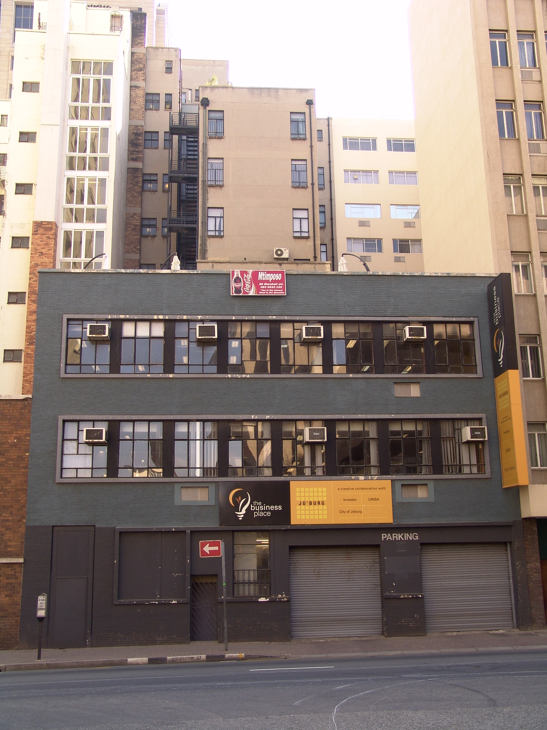
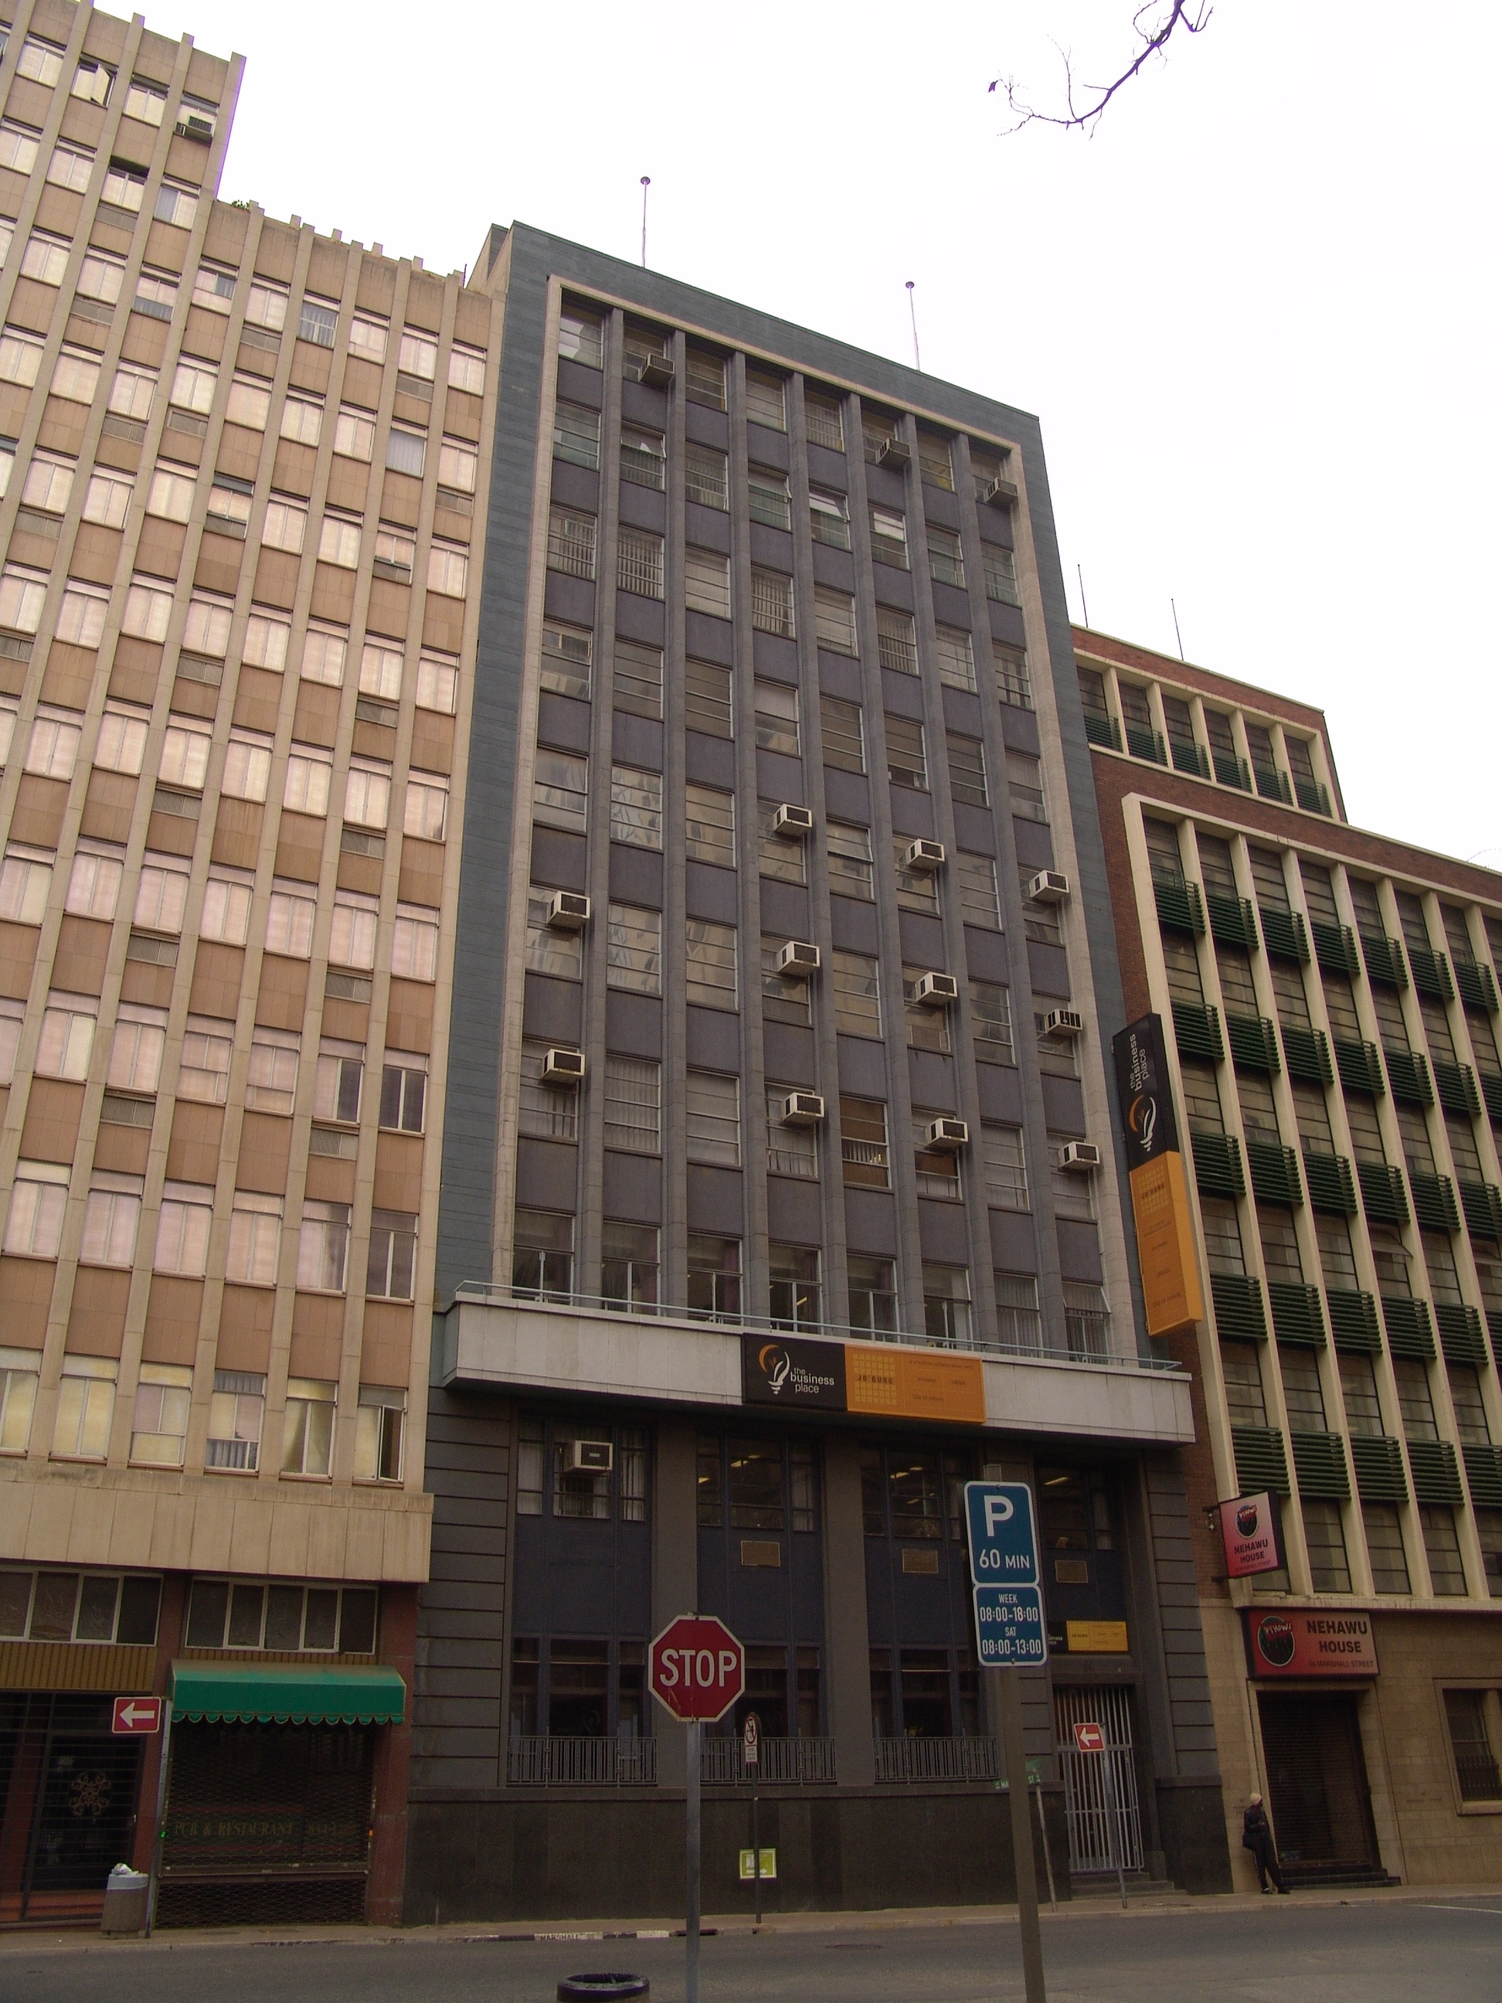

Photograph: Catharina JM Bruwer.

Above left: View of the Marshall Street façade of Dominion House to the centre of the photograph, with Nehawu House to the right, and Khotso House to the left. (CJMB)

Above right: Anderson Street façade. (CJMB)

Previous/alternative name/s : by 1954 – Dominion Insurance House
: currently - The Business Place
:

LOCATION: Street : Marshall, Anderson
Street number : 58 Marshall
: (58 Marshall; 21 Anderson)
Stand Number : 1163
Previous Stand Number: 89, 98
Block number : CI
Suburb : Marshallstown
GIS reference :

ZONING: Current use/s :
Previous use/s :

DESCRIPTION OF PLACE:

Height :
Levels above street level : Marshall Street - 10 plus staff quarters to roof
Levels above street level : Anderson Street - three
Levels below street level : one
On-site parking : yes
(CJMB)

“When Henri Joubert of Kennedy, Furner, Irvine-Smith & Joubert (the successors to the old firm of Kallenbach, Kennedy & Furner)” according to Chipkin “came along a year later to design Dominion House in 1950 on the stand next door to Libertas, he picked up the modular vertical theme previously established on Janks’s building. In the process he also added a surrounding frame and a high degree of refinement in the profiling and coursing of the precast facings. The result was both a good neighbour and an infill building of high quality and sophistication. Thus a crystallising street tradition bearing strong regional and type characteristics was developing in this part of town on the site of former low garaging and nondescript buildings of the 1920s.”
(Chipkin, C.M.: Johannesburg Style; Architecture & Society…).

See electronic version of Survey Report for copies of the original building plans.
(CJMB)

CONSTRUCTION MATERIALS:

Plinth: granite

Walls: brick faced with artificial stone

Roof: concrete

Windows: steel frame
(CJMB)

SITE FEATURES:

ALTERATIONS:

During 1952 the architectural firm of Kennedy, Furner, Irvine-Smith & Joubert submitted plans to link Khotso House (originally known as Libertas) and Dominion Insurance House. (CJMB)

INTEGRITY:

The integrity of the aesthetic attributes of the building was partially compromised when the owners painted the façade. This destroyed the harmonized relationship between Dominion House and its neighbour Nehawu House (originally Libertas). The air-conditioning units to the exterior of the building look like warts and detract from the façade. (CJMB)

INSCRIPTION:

ARCHITECT:

Kennedy, Furner, Irvine-Smith & Joubert
(Address: 72 Sacke’s Buildings, Joubert Street, Johannesburg.)

BUILDER:

CONSTRUCTION DATE:

Date on plans : 14 June 1950
Approval of plans : 11 December 1950
Completion date :
(CJMB)

BUILDING STYLE:

Johannesburg Modular Regionalism

Architectural Merit: “This building is very ahead of its time in its use of material and colour in the façade, and follows the modular regionalism tradition of the time in a new and inventive way, which did not become a main stream approach.”
(Johannesburg Building, Space & Urban Feature Classification, 1998: Inner City).

BUILDING TYPE:

Office building. (CJMB)

ENVIRONMENT:

CONDITION:

The condition of the main (Marshall Street) façade of the building appears to be fair; this is in contrast to the neglected Anderson Street façade which requires cosmetic repairs. (CJMB)

URGENT ACTION:

SAHRA RECORD REGARDING ALTERATIONS, RENOVATIONS, RESTORATION:

PROTECTION STATUS: (under National Heritage Resources Act, 1999)

General protection: Section 34(1) structure/s

Formal protection: provincial heritage site

national heritage site

provisional protection

heritage area

listed in provincial heritage
resources register

Relevant Gazette Notice:

Gazette description:

FORMER PROTECTION STATUS: (under National Monuments Act, 1969)

NOTES:

DEEDS INFORMATION:

Original ownership: S. A. Subsidiary Investments Ltd.
P. O. Box 1653, Johannesburg.
(CJMB)

PRE-HISTORY OF SITE:

HISTORY:

GENERAL NOTES:

Estimated cost of building : £70 000.00
Estimated cost of drainage : £2 000.00
Accommodation approved : 10 ‘Natives’
Valuation at completion :
Occupied : yes
(CJMB)

PREVIOUS TENANT/S:

By 1954:
The Dominion Insurance Company of South Africa Ltd.
(The Rand-Pretoria Directory 1954 (Comprising Complete Alphabetical And Trades Directories of Johannesburg, Pretoria And Reef Towns), Cape Times Limited, Cape Town, 1954.)

CURRENT TENANT/S:

The Business Place; Mtimposo.

SOURCES:

Published Sources

Chipkin, C.M.: Johannesburg Style; Architecture & Society 1880s – 1960s, David Philip Publishers, Cape Town, 1993.
The Rand-Pretoria Directory 1954 (Comprising Complete Alphabetical And Trades Directories of Johannesburg, Pretoria And Reef Towns), Cape Times Limited, Cape Town, 1954.

Unpublished Sources
Johannesburg Building, Space & Urban Feature Classification, 1998: Inner City - Metropolitan Planning, Johannesburg Metropolitan Council (Cool Factory).
Plans records of surveyed buildings, Marshallstown and City of Johannesburg: Archives, Building Control, Development Management, City of Johannesburg Metropolitan Municipality.

ASSESSMENT OF CULTURAL SIGNIFICANCE:

Historic Value:

Associated with historic person, group or organisation

Associated with historic event or activity

Architectural/Aesthetic value:

Important example of building type

Important example of a style or period

Fine details, workmanship or aesthetics

Work of a major architect or builder

Social/Spiritual/Linguistic value:

Associated with social, spiritual, linguistic, economic or political activity

Illustrates an historical period

Scientific/Technological value:

Example of industrial, technical or engineering development/achievement

New, rare or experimental building techniques

RECORDED BY:


Heritage Resources Management team Johann J Bruwer and Alezea Bruwer.

And Catharina JM Bruwer.

Photographs (unless otherwise indicated) by Johann J Bruwer and Alezea Bruwer.

