CATALOGUE NO: BX-5 DATE RECORDED: JANUARY – JUNE 2006
__________________________________________________________________

JOHANNESBURG METROPOLITAN MUNICIPALITY

HERITAGE ASSESSMENT SURVEYING FORM
__________________________________________________________________

Compiled by: Dr JJ Bruwer, 2002-07-29 JJ Bruwer ©
Cellphone: +27 82 325 5823

NAME OF PLACE: MAIN HOUSE

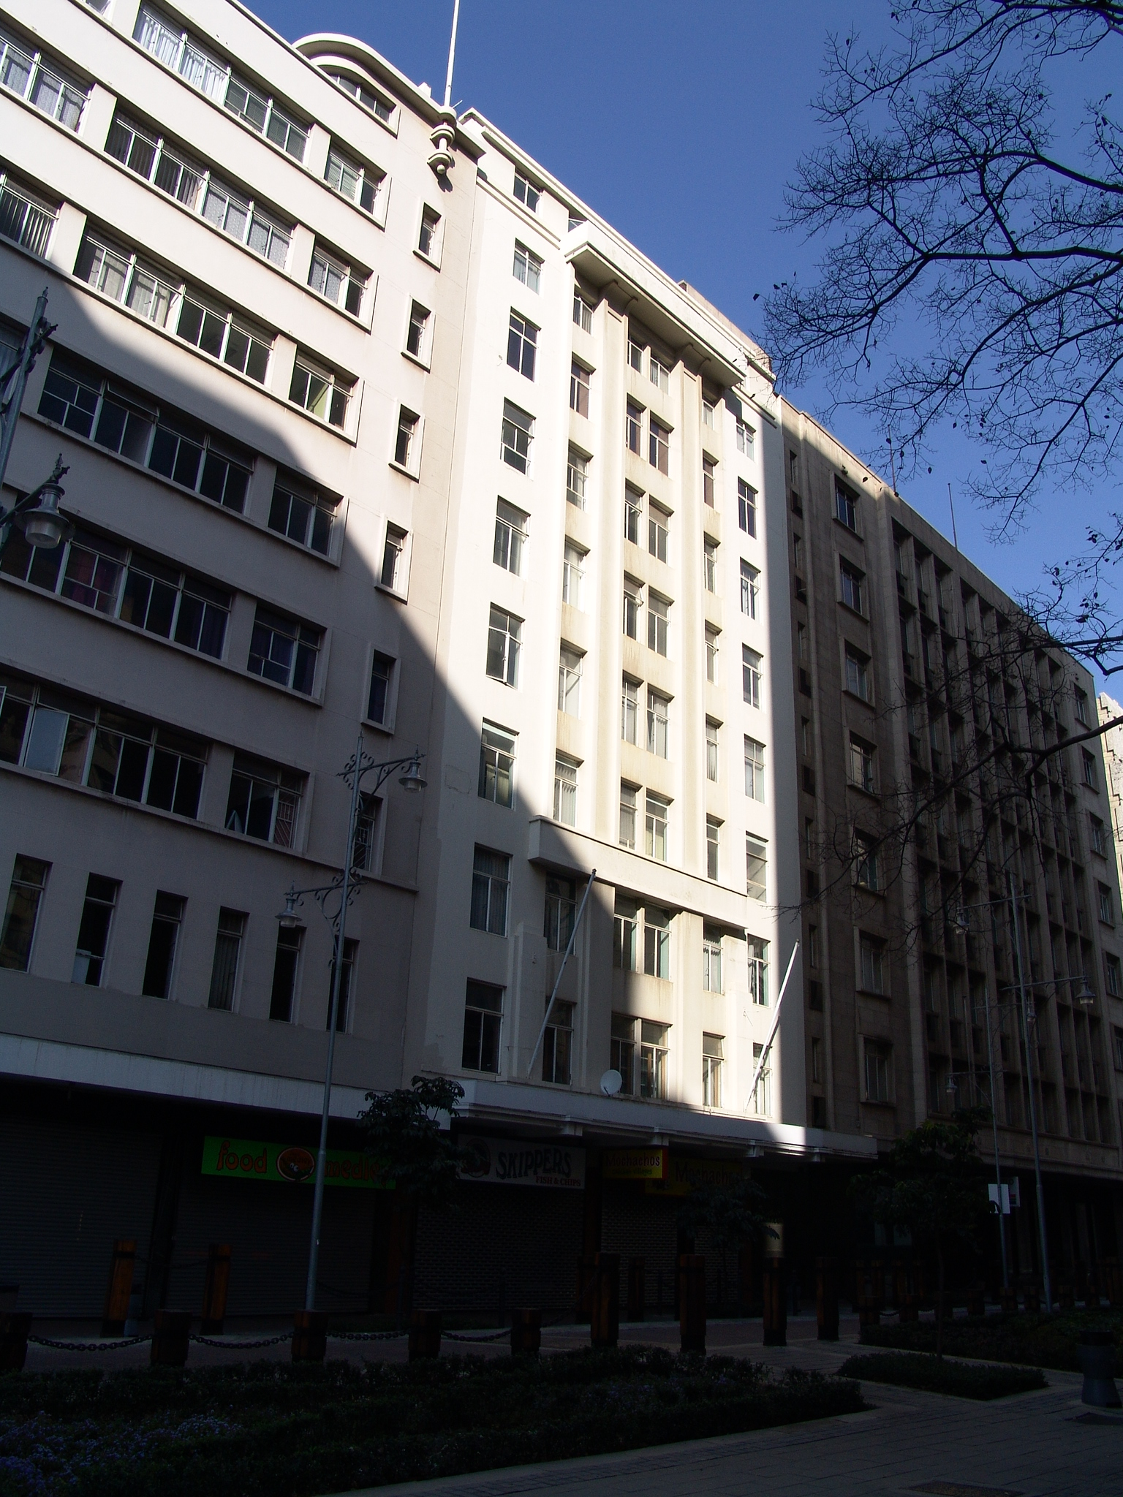

Photograph: Catharina JM Bruwer.

Above: View of Main House, with Howard House on the left, and Matlotlo House, on the right.

Previous/alternative name/s :
:
:

LOCATION: Street : Main
Street number : 96
Stand Number : 205
Previous Stand Number:
Block number : BX
Suburb : Marshallstown
GIS reference :

ZONING: Current use/s :
Previous use/s :

DESCRIPTION OF PLACE:

Height :
Levels above street level : eleven
Levels below street level :
On-site parking :

CONSTRUCTION MATERIALS:

Walls:

Roof:

Windows:

Verandah: cantilevered.
(CJMB)

SITE FEATURES:

ALTERATIONS:

No plans record found.

INTEGRITY:

In an effort to ‘modernize’ the building, the owners removed the moulded plaster name of the building as well as moulded plaster relief work to the balcony. The author feels strongly about the preservation of historic names of buildings, and suggests these should be protected. See electronic version of Survey Report for a postcard showing the building when still in a pristine condition. (CJMB)

INSCRIPTION:

ARCHITECT:

D.L. Nurcombe, 1935

Nurcombe & Summerley
‘…a partnership in Johannesburg between DL Nurcombe and HG Summerley from February 1936; the practice flourished and in 1936 won the prestigious competition for the design of the Master Builders' Association Headquarters in Johannesburg. Their best-known building however was Chrysler House, Johannesburg (1936-9). The firm later (n.d.) became Nurcombe, Summerley & Lange.’
(Architects In South Africa 1780 – 1940; Draft manuscript, J Walker & G M van der Waal, 1992, HSRC, Pretoria.)

BUILDER:

CONSTRUCTION DATE:

Date on plans :
Approval of plans : 1935
Completion date :
(CJMB)

BUILDING STYLE:

Art Deco – Monolithic.

BUILDING TYPE:

This is a shop to street and office building. (CJMB)

ENVIRONMENT:

CONDITION:

The building requires cosmetic repair work. (CJMB)

URGENT ACTION:

SAHRA RECORD REGARDING ALTERATIONS, RENOVATIONS, RESTORATION:

PROTECTION STATUS: (under National Heritage Resources Act, 1999)

General protection: Section 34(1) structure/s

Formal protection: provincial heritage site

national heritage site

provisional protection

heritage area

listed in provincial heritage
resources register

Relevant Gazette Notice:

Gazette description:

FORMER PROTECTION STATUS: (under National Monuments Act, 1969)

NOTES:

DEEDS INFORMATION:

Original ownership: Main House (Pty.) Ltd.
(CJMB)

PRE-HISTORY OF SITE:

HISTORY:

GENERAL NOTES:

Estimated cost of building :
Estimated cost of drainage :
Accommodation approved :
Valuation at completion :
Occupied : yes
(CJMB)

PREVIOUS TENANT/S:

CURRENT TENANT/S:

Skippers Fish & Chips
Mochachos Chicken Villages

SOURCES:

Published Sources
Chipkin, C.M.: Johannesburg Style; Architecture & Society 1880s – 1960s, David Philip Publishers, Cape Town, 1993.
The Rand-Pretoria Directory 1954 (Comprising Complete Alphabetical And Trades Directories of Johannesburg, Pretoria And Reef Towns), Cape Times Limited, Cape Town, 1954.
Van Der Waal, G-M.: From Mining Camp to Metropolis, The buildings of Johannesburg 1886-1940, Chris Van Rensburg Publications, Johannesburg, 1987.

Unpublished Sources
Architects In South Africa 1780 – 1940; Draft manuscript, J Walker & G M van der Waal, 1992, HSRC, Pretoria.
Plans records of surveyed buildings, Marshallstown and City of Johannesburg: Archives, Building Control, Development Management, City of Johannesburg Metropolitan Municipality.
Johannesburg Building, Space & Urban Feature Classification, 1998: Inner City - Metropolitan Planning, Johannesburg Metropolitan Council (Cool Factory).
Opname Historiese Geboue In Johannesburg, Second Report June 1976, Inner City, RAU, unpublished.
Van Der Waal, G-M.: Die Karakter Van Die Argitektuur In Die Binnestad Van Johannesburg Tot 1920, unpublished thesis, RAU, November 1972.
Van Der Waal, G-M.: Die Boukuns van Johannesburg, 1886 – 1940, unpublished doctoral thesis, RAU, November 1984.

ASSESSMENT OF CULTURAL SIGNIFICANCE:

Historic Value:

Associated with historic person, group or organisation

Associated with historic event or activity

Architectural/Aesthetic value:

Important example of building type

Important example of a style or period

Fine details, workmanship or aesthetics

Work of a major architect or builder

Social/Spiritual/Linguistic value:

Associated with social, spiritual, linguistic, economic or political activity

Illustrates an historical period

Scientific/Technological value:

Example of industrial, technical or engineering development/achievement

New, rare or experimental building techniques

RECORDED BY:


Heritage Resources Management team Johann J Bruwer and Alezea Bruwer.

And Catharina JM Bruwer.

Photographs (unless otherwise indicated) by Johann J Bruwer and Alezea Bruwer.

