CATALOGUE NO: CH-1 DATE RECORDED: JANUARY – JUNE 2006
__________________________________________________________________

JOHANNESBURG METROPOLITAN MUNICIPALITY

HERITAGE ASSESSMENT SURVEYING FORM
__________________________________________________________________

Compiled by: Dr JJ Bruwer, 2002-07-29 JJ Bruwer ©
Cellphone: +27 82 325 5823

NAME OF PLACE: UNICORN HOUSE

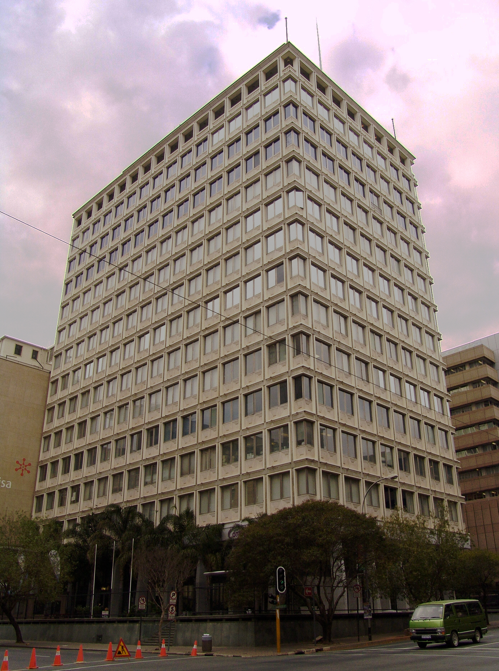

Photograph: Catharina JM Bruwer.

Above: The Marshall (left) and Sauer (right) street elevations of Unicorn House. (CJMB)

Previous/alternative name/s :
:
:

LOCATION: Street : corners Marshall, Sauer and Anderson
Street number : 70 Marshall
: (68, 70, 72 Marshall; 8, 10 Sauer; 31, 33, 35 Anderson)
Stand Number : 1112
Previous Stand Number:
Block number : CH
Suburb : Marshallstown
GIS reference :

ZONING: Current use/s :
Previous use/s :
DESCRIPTION OF PLACE:

Height :
Levels above street level : 15
Levels below street level :
On-site parking :

A striking building designed to make a statement of progress and modernism. (CJMB)

CONSTRUCTION MATERIALS:

Walls: reinforced concrete frame, ornamental metal panels

Roof: flat, concrete

Windows: aluminium frame

SITE FEATURES:

A five stamp battery as ornament to the building on Marshall Street with Palm trees surrounding the building. (CJMB)

ALTERATIONS:

INTEGRITY:

INSCRIPTION:

ARCHITECT:

BUILDER:

CONSTRUCTION DATE:

Date on plans :
Approval of plans :
Completion date :

BUILDING STYLE:

Johannesburg Modular Regionalism. 1960s

BUILDING TYPE:

Shops to street and office building. (CJMB)

ENVIRONMENT:

Unfortunately this excellent building was not designed to match the scale or fabric of its immediate neighbours. (CJMB)

CONDITION:

The condition of the building (as seen from the exterior) appears to be good.

URGENT ACTION:
SAHRA RECORD REGARDING ALTERATIONS, RENOVATIONS, RESTORATION:

PROTECTION STATUS: (under National Heritage Resources Act, 1999)

General protection: Section 34(1) structure/s

Formal protection: provincial heritage site

national heritage site

provisional protection

heritage area

listed in provincial heritage
resources register

Relevant Gazette Notice:

Gazette description:

FORMER PROTECTION STATUS: (under National Monuments Act, 1969)

NOTES:

DEEDS INFORMATION:

Original ownership:

PRE-HISTORY OF SITE:

HISTORY:

GENERAL NOTES:

Estimated cost of building :
Estimated cost of drainage :
Accommodation approved :
Valuation at completion :
Occupied :

PREVIOUS TENANT/S:

CURRENT TENANT/S:

Dulcé Café
Computershare

SOURCES:

ASSESSMENT OF CULTURAL SIGNIFICANCE:

Historic Value:

Associated with historic person, group or organisation

Associated with historic event or activity

Architectural/Aesthetic value:

Important example of building type

Important example of a style or period

Fine details, workmanship or aesthetics

Work of a major architect or builder

Social/Spiritual/Linguistic value:

Associated with social, spiritual, linguistic, economic or political activity

Illustrates an historical period

Scientific/Technological value:

Example of industrial, technical or engineering development/achievement

New, rare or experimental building techniques

RECORDED BY:


Heritage Resources Management team Johann J Bruwer and Alezea Bruwer.

And Catharina JM Bruwer.

Photographs (unless otherwise indicated) by Johann J Bruwer and Alezea Bruwer.

