CATALOGUE NO: CH-2 DATE RECORDED: JANUARY – JUNE 2006
__________________________________________________________________

JOHANNESBURG METROPOLITAN MUNICIPALITY

HERITAGE ASSESSMENT SURVEYING FORM
__________________________________________________________________

Compiled by: Dr JJ Bruwer, 2002-07-29 JJ Bruwer ©
Cellphone: +27 82 325 5823

NAME OF PLACE: UNION CORPORATION BUILDING

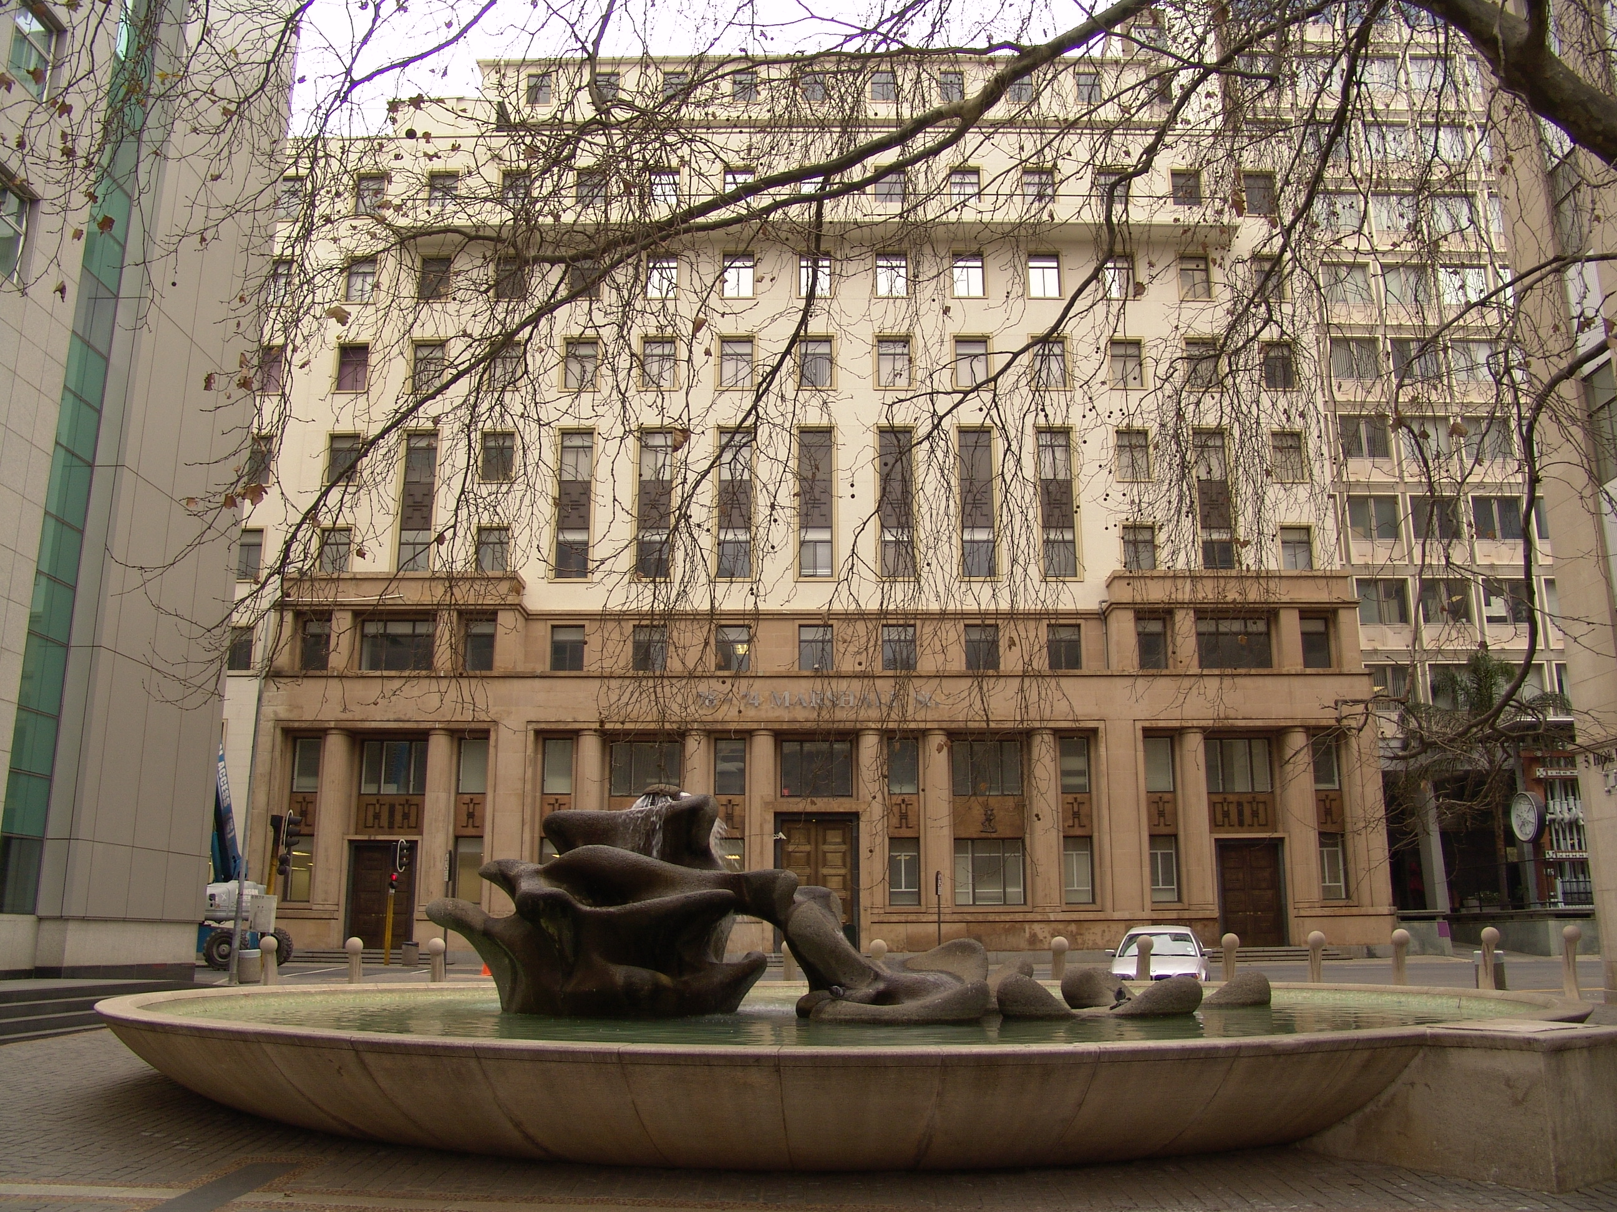

Photograph: Catharina JM Bruwer.

Above: View of the main façade of the Union Corporation Building as seen from Hollard Street. (CJMB)

Previous/alternative name/s :
:
:

LOCATION: Street : Marshall, Anderson
Street number : 74, 76, 78 Marshall
: (74, 76, 78 Marshall; 37, 39, 41 Anderson)
Stand Number : 1167
Previous Stand Number:
Block number : CH
Suburb : Marshallstown
GIS reference :

ZONING: Current use/s :
Previous use/s :

DESCRIPTION OF PLACE:

Height :
Levels above street level : nine
Levels below street level :
On-site parking :

CONSTRUCTION MATERIALS:

Plinth: unpolished granite

Walls:

Roof: flat, concrete

Windows: aluminium frame
(CJMB)

SITE FEATURES:

ALTERATIONS:

INTEGRITY:

Whoever decided to paint the upper section of the main façade of the building had no intention to honour this finely designed building. The integrity of the building has been partially compromised by the painting of the main façade. (CJMB)
Apart from this, the integrity of the original design and materials of the exterior of the building, appears largely intact.
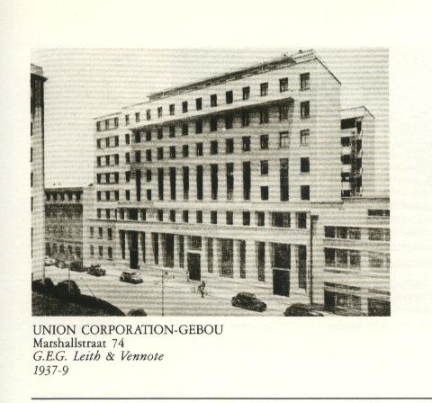

This early photograph (reproduced from Van Der Waal, G-M.: From Mining Camp to Metropolis…,), shows the main façade of the building, shortly after the completion of the building. This was long before the painting of part of the main facade.

INSCRIPTION:

ARCHITECT:

G. E. G. Leith & Partners

Leith, George Esselmont Gordon
‘…(23 May 1886 - 1965), Leith is best known as one of the masters of the so-called traditional style in South Africa during the first half of this century. His classicist designs for official bodies, especially in the bigger towns and cities in the Transvaal, such as Reserve banks, town halls and technical colleges, secured his place in the public eye. In this respect he associated himself with the 'Grand Manner' learnt in both the Public Works Department through Herbert BAKER's influence on that Department, and almost certainly in Baker's office and Italy. Leith's
participation in modern architecture are not so well known, but he was among the very first South African to contribute to the 'New Style' round about 1931 with the design of Downing Mansions in Johannesburg, before the MARTIENSSEN group's International Style emerged in about 1933/1934. Leith did not share the Martienssen group's ideological basis of seeing architecture as an instrument to change society. Rather did he use it as a formal alternative to his traditional work. The several modernistic hospitals by him in Johannesburg confirm his interest in modern outward form. The interiors perpetuate the concept of isolated spaces characteristic of traditional style combining rational massing with a sensitivity to site and environment and with the rich textural effects of natural materials. Subsequently he made more use of Mediterranean references in domestic work, found mostly at that time in Johannesburg. In his tribute to Leith in 1965, Norman EATON commented that he saw Leith as a link figure between the classical and the modern in architecture (SAAR May 1965;47.)
Leith was born in Knysna, Cape Province and educated at the Staats Model Skool in Pretoria, his family having moved to Pretoria in 1889. During the Anglo-Boer War he spent time drawing and modelling under Van Wouw's guidance. In this circle he made the acquaintance of Henk Pierneef, Fanie Eloff, Frans Oerder, Gerard MOERDYK and Henri ten Brink, the latter taught him the violin. According to Eaton's account of Leith's life, in Eaton's obituary of him (SAAR May 1965:12, 47), Leith 'served a short apprenticeship in the Pretoria Railways workshop in 1902' as an apprentice fitter, while still continuing with his drawing classes. Van Wouw's bronze statuette 'the student' (now in the South African Akademie vir Wetenskap en Kuns, Pretoria) is said to be a study of Leith at this time.
In October 1902 he was employed by the Public Works Department in Pretoria where according to the Civil Service Lists of the Transvaal (1905:98), he was a draughtsman or tracer. The Rand Daily Mail (14 Aug 1946) confirms this but adds that that Leith was apprenticed to Van Wouw in 1903 and was a tracer the Public Works Department from 1903 to 1905.
Leith remained with the Department until August 1905 according to several sources, including his papers for Associate membership of the RIBA (1907). From 1905 until 1907 he studied at the Architectural Association in London. According to Eaton (SAAR May 1965:12) Leith showed such promise that 'a deputation of fellow draughtsmen appealed to his family to find ways and means of sending him to study overseas ... funds were raised to send him to the Architectural Association in London.' Here he studied from September 1905 until July 1907; Stamp (1981) says Leith was sent to London by Hugh Crawford and that he remained in Britain from 1906 until 1909. This disagrees with the information in Leith's RIBA nomination papers and with Leith's own note in the ISAA records which state he was back with the PWD in 1907, remaining until 1908 and the account in the Rand Daily Mail (14.8.1946). Thomas TYRWHITT, the assistant chief architect of the Public Works Department in about 1905, is also alleged to have encouraged Leith to study in England.
Leith was elected an Associate member of the Royal Institute of British Architects in 1907 and his papers were witnessed by W BEVAN in London who noted Leith 'was employed directly under me in the Public Works Department, Transvaal.' He was successful in his studies at the Architectural Association and while in London he worked in the offices of Hendry White, FRIBA, and of Claude Farrier and spent 'six months travelling in Normandy, Scotland, England and Ireland' (ARIBA nom papers 1907) before returning to Pretoria in 1907. Here, under the chief architect P EAGLE and a draughtsman JN CORMACK, Leith prepared plans for a 'vast Government complex of buildings - including Houses of Parliament - for the Union Government' (SAAR May 1965). Although it was decided to keep parliament in Cape Town, the plans seem to have provided the basis for the Union Buildings scheme.
In 1908, following an argument with the Public Works Department over the Law Courts in Johannesburg (Eaton SAAR May 1965:46), Leith entered Herbert Baker's office with whom he remained from 1908 until 1910. His address in 1909 was 'Craig-Leith' in Muckleneuk, Pretoria - Craig Leith being a type of stone found in Scotland. His association with Baker was marked by disagreements. According to Hoffe (1954), Leith had not heard of Baker before he joined his staff. But he later averred that he respected Baker from the first, admiring his attention to detail - stating 'Baker was my man' (Hoffe 1954), and Leith was given considerable responsibility for detail drawings. In spite of being temporarily banned from Baker's office for some unrevealed insult to Baker, becoming a Baker protege and in 1911 was awarded the first Baker Scholarship (Leith gives 1910 in his RIBA papers). His prizewinning essay was entitled 'The principles dominating architectural design in South Africa' (Afr Archt Sep 1911:89-90). In 1910 Leith and J FILTNESS won second prize for the layout of Church Square, Pretoria. As a Baker Scholar Leith travelled to Italy to study at the British School at Rome and at the British School at Athens between 1910 and 1913. He was in London in 1910 since he and GLP Moerdyk had dinner together (Moerdyk's letters, HSRC doc), his address during 1911/1912 in South Africa was c/o A Van Wouw, 111 Sivewright Avenue, Johannesburg. In Rome he surveyed the Flavian palace on the Palatine Hill and made outstanding reconstruction drawings of the palace.
Leith worked briefly in London in Baker's office, assisting with drawings for New Delhi. He returned to South Africa in 1913, working in Johannesburg where he taught at the School of Mines and Technology in Johannesburg from 1913 to 1916. He married in 1914 and in 1915 enlisted for active service. A commissioned officer in the Royal Flying Corps, he left for Britain in 1916, his lungs were permanently affected by mustard gas suffered while in France. At Armistice Baker recommended that Leith be included in the team of architects serving on the Imperial War Graves Commission, Leith was appointed an assistant architect to the Commission in December 1918. Both Baker and Edwin LUTYENS played important roles in the Commission and Leith came under the influence of both men. Leith was appointed senior designing architect to the Commission in succession to Charles Holden on 1 April 1920, but resigned on 1 July 1920 owing to ill health and was repatriated to South Africa.
Leith returned to Pretoria for a short time but finally settled in Johannesburg where he took up part-time lecturing again at the 'Tin Temple' (the wood and iron buildings of the School of Mining and Engineering) and set up practice in 1921 in Johannesburg. For a time he appears to have shared an office or a floor in a building with an elderly Dutch architect, JH BREYER. A number of Leith's jobs from these days refer to original plans by Breyer who retired to live in Holland sometime between 1927 and 1932.
Leith's office attracted a number of student architects, among them JP NELSON and AFR COOK who were working there at the time Norman Eaton joined the office in 1924, Eaton being articled to Leith in 1924 and in 1926 (on Leith winning the Pretoria Technical College competition) was placed in charge of a branch office opened to handle the job in Pretoria. About this time Leith is said to have persuaded Kirkness to produce Etruscan tiles, the first in South Africa, hitherto imported. Leith's overseas studies developed his enthusiasm for vaulted and domed structures, an interest he shared with Moerdyk with whom he later codesigned the Johannesburg Railway Station (1926-1931), exhibiting drawings of the station in the South African Academy Exhibition of 1927 under the joint names of McCUBBIN, Leith & Moerdyk.
Leith won two competitions about this time, for the Pretoria War Memorial and for the Pretoria Technical College. He invited Norman Eaton, still a student, to run the Pretoria office. Winning the competition for the Pretoria Technical College and his carrying out of the Rand Water Board Building in Johannesburg (1925-1927) ensured Leith's reputation. He had attained a position left vacant by Baker as architect to the hierarchy in the Transvaal and he designed an increasing number of public buildings while keeping up with a steady demand for private housing.
In 1930 Leith was elected a Fellow of the Royal Institute of British Architects and Baker made the following note on Leith's application form: 'I saw two years ago a good many of his works in South Africa and formed a specially high opinion of his Rand Water Board Building...his Johannesburg Railway Station bids fair to be a noble building. Leith has exceptional skill in design and the sense of modelling of complicated vaulted and domical structures. His early apprenticeship as a sculptor has given him too, a keen sense of perception of the relationship of sculpture to architecture. He wins golden opinions everywhere for his keenness in the profession and sterling character'.
Leith won the competition for the Bloemfontein Town Hall in 1930, in many ways the definitive building of the extended Baker tradition. In about 1931 he designed Barclays Bank, Cape Town, with Douglas HOETS. Leith travelled to Europe in 1932 where he spent 'some weeks in England, Germany and Sweden' (SAAR Jan 1933:15), perhaps in preparation for his appointment as architect of the South African Reserve Bank in Johannesburg in 1933, and to Barclays Bank in the Transvaal. In 1933 he won the competition for the Germiston Town Hall and during the 1930s designed several hospitals in Johannesburg, including buildings for the Johannesburg General Hospital (1935-1939) and the Chamber of Mines Hospital in Cottesloe (1939-1942). In both cases the work was restrained and utilitarian.
In the last years of his life Leith developed his interests in viticulture (a grape cultivar was named after him), water supplies and soil erosion. He proposed, for example, the breeding of the praying mantis to keep grapes free from pests, and was an active member of the Associated Scientific and Technical Club. Leith built two houses for himself in the 1940s in Johannesburg, Harthill (1943) and Esselmont (1946), and had a house at Farm Kairo. He apparently designed a projected house for Yeta III, Paramount Chief of Barotseland, Mongi-Lealui, Barotseland, Northern Rhodesia in 1935. As advisory architect to the South African Agency of the War Graves Commission in 1950, he worked on the design of war cemeteries in South Africa. On his death the words of one of a colleague record Leith's contribution to contemporary life: 'To those who were privileged to know him well the loss of this link with a more measured and humane interval in the social and architectural history of South Africa and the passing of this unique personality who belonged to it is sad indeed' (SAAR May 1965:47)…’
(Architects In South Africa 1780 – 1940; Draft manuscript, J Walker & G M van der Waal, 1992, HSRC, Pretoria.)

BUILDER:

CONSTRUCTION DATE:

Date on plans :
Approval of plans : 1937
Completion date : 1939

BUILDING STYLE:

Art Deco - New York.

Architectural Merit: “An influential building of its time, and a good example of its type.” (Johannesburg Building, Space & Urban Feature Classification, 1998: Inner City).

BUILDING TYPE:

This is an office block. (CJMB)

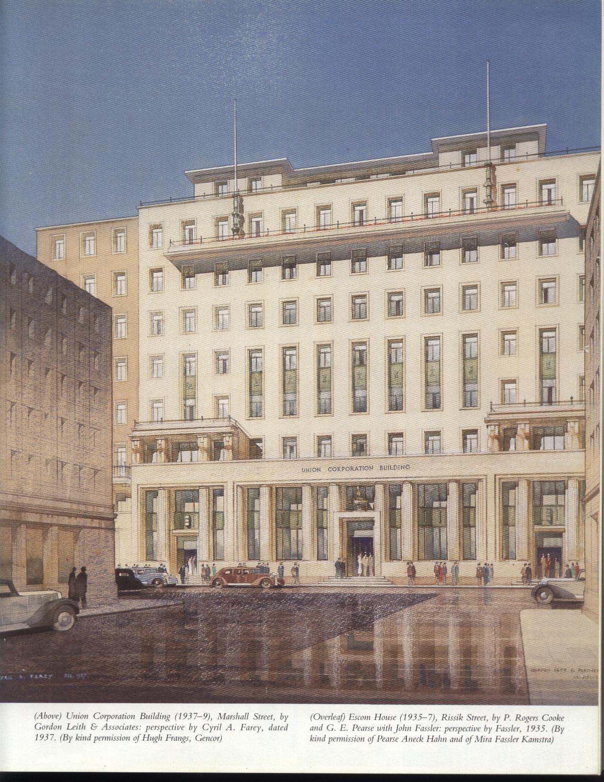

Above: Perspective of the Union Corporation Building by Cyril A. Farey, dd. 1937 (From Chipkin, C.M.: Johannesburg Style; Architecture & Society 1880s-1960s).

ENVIRONMENT:

CONDITION:

The condition of the building (as seen from the outside) appears to be good.

URGENT ACTION:

SAHRA RECORD REGARDING ALTERATIONS, RENOVATIONS, RESTORATION:

PROTECTION STATUS: (under National Heritage Resources Act, 1999)

General protection: Section 34(1) structure/s

Formal protection: provincial heritage site

national heritage site

provisional protection

heritage area

listed in provincial heritage
resources register

Relevant Gazette Notice:

Gazette description:

FORMER PROTECTION STATUS: (under National Monuments Act, 1969)

NOTES:

DEEDS INFORMATION:

Original ownership:

PRE-HISTORY OF SITE:

HISTORY:

GENERAL NOTES:

Estimated cost of building :
Estimated cost of drainage :
Accommodation approved :
Valuation at completion :
Occupied :

PREVIOUS TENANT/S:

Johannesburg Branch office of Pretoria Portland Cement Co. Ltd. (The Rand-Pretoria Directory 1954).

CURRENT TENANT/S:

SOURCES:

Published Sources
Van Der Waal, G-M.: From Mining Camp to Metropolis, The buildings of Johannesburg 1886-1940, Chris Van Rensburg Publications, Johannesburg, 1987.
Chipkin, C.M.: Johannesburg Style; Architecture & Society 1880s-1960s, David Philip, Cape Town, 1993.

Unpublished Sources
Architects In South Africa 1780 – 1940; Draft manuscript, J Walker & G M van der Waal, 1992, HSRC, Pretoria.
Johannesburg Building, Space & Urban Feature Classification, 1998: Inner City - Metropolitan Planning, Johannesburg Metropolitan Council (Cool Factory).

ASSESSMENT OF CULTURAL SIGNIFICANCE:

Historic Value:

Associated with historic person, group or organisation

Associated with historic event or activity

Architectural/Aesthetic value:

Important example of building type

Important example of a style or period

Fine details, workmanship or aesthetics

Work of a major architect or builder

Social/Spiritual/Linguistic value:

Associated with social, spiritual, linguistic, economic or political activity

Illustrates an historical period

Scientific/Technological value:

Example of industrial, technical or engineering development/achievement

New, rare or experimental building techniques

RECORDED BY:


Heritage Resources Management team Johann J Bruwer and Alezea Bruwer.

And Catharina JM Bruwer.

Photographs (unless otherwise indicated) by Johann J Bruwer and Alezea Bruwer.

