CATALOGUE NO: AU-1 DATE RECORDED: JANUARY – JUNE 2006
__________________________________________________________________

JOHANNESBURG METROPOLITAN MUNICIPALITY

HERITAGE ASSESSMENT SURVEYING FORM
__________________________________________________________________

Compiled by: Dr JJ Bruwer, 2002-07-29 JJ Bruwer ©
Cellphone: +27 82 325 5823

NAME OF PLACE: AFRICAN CITY BUILDING

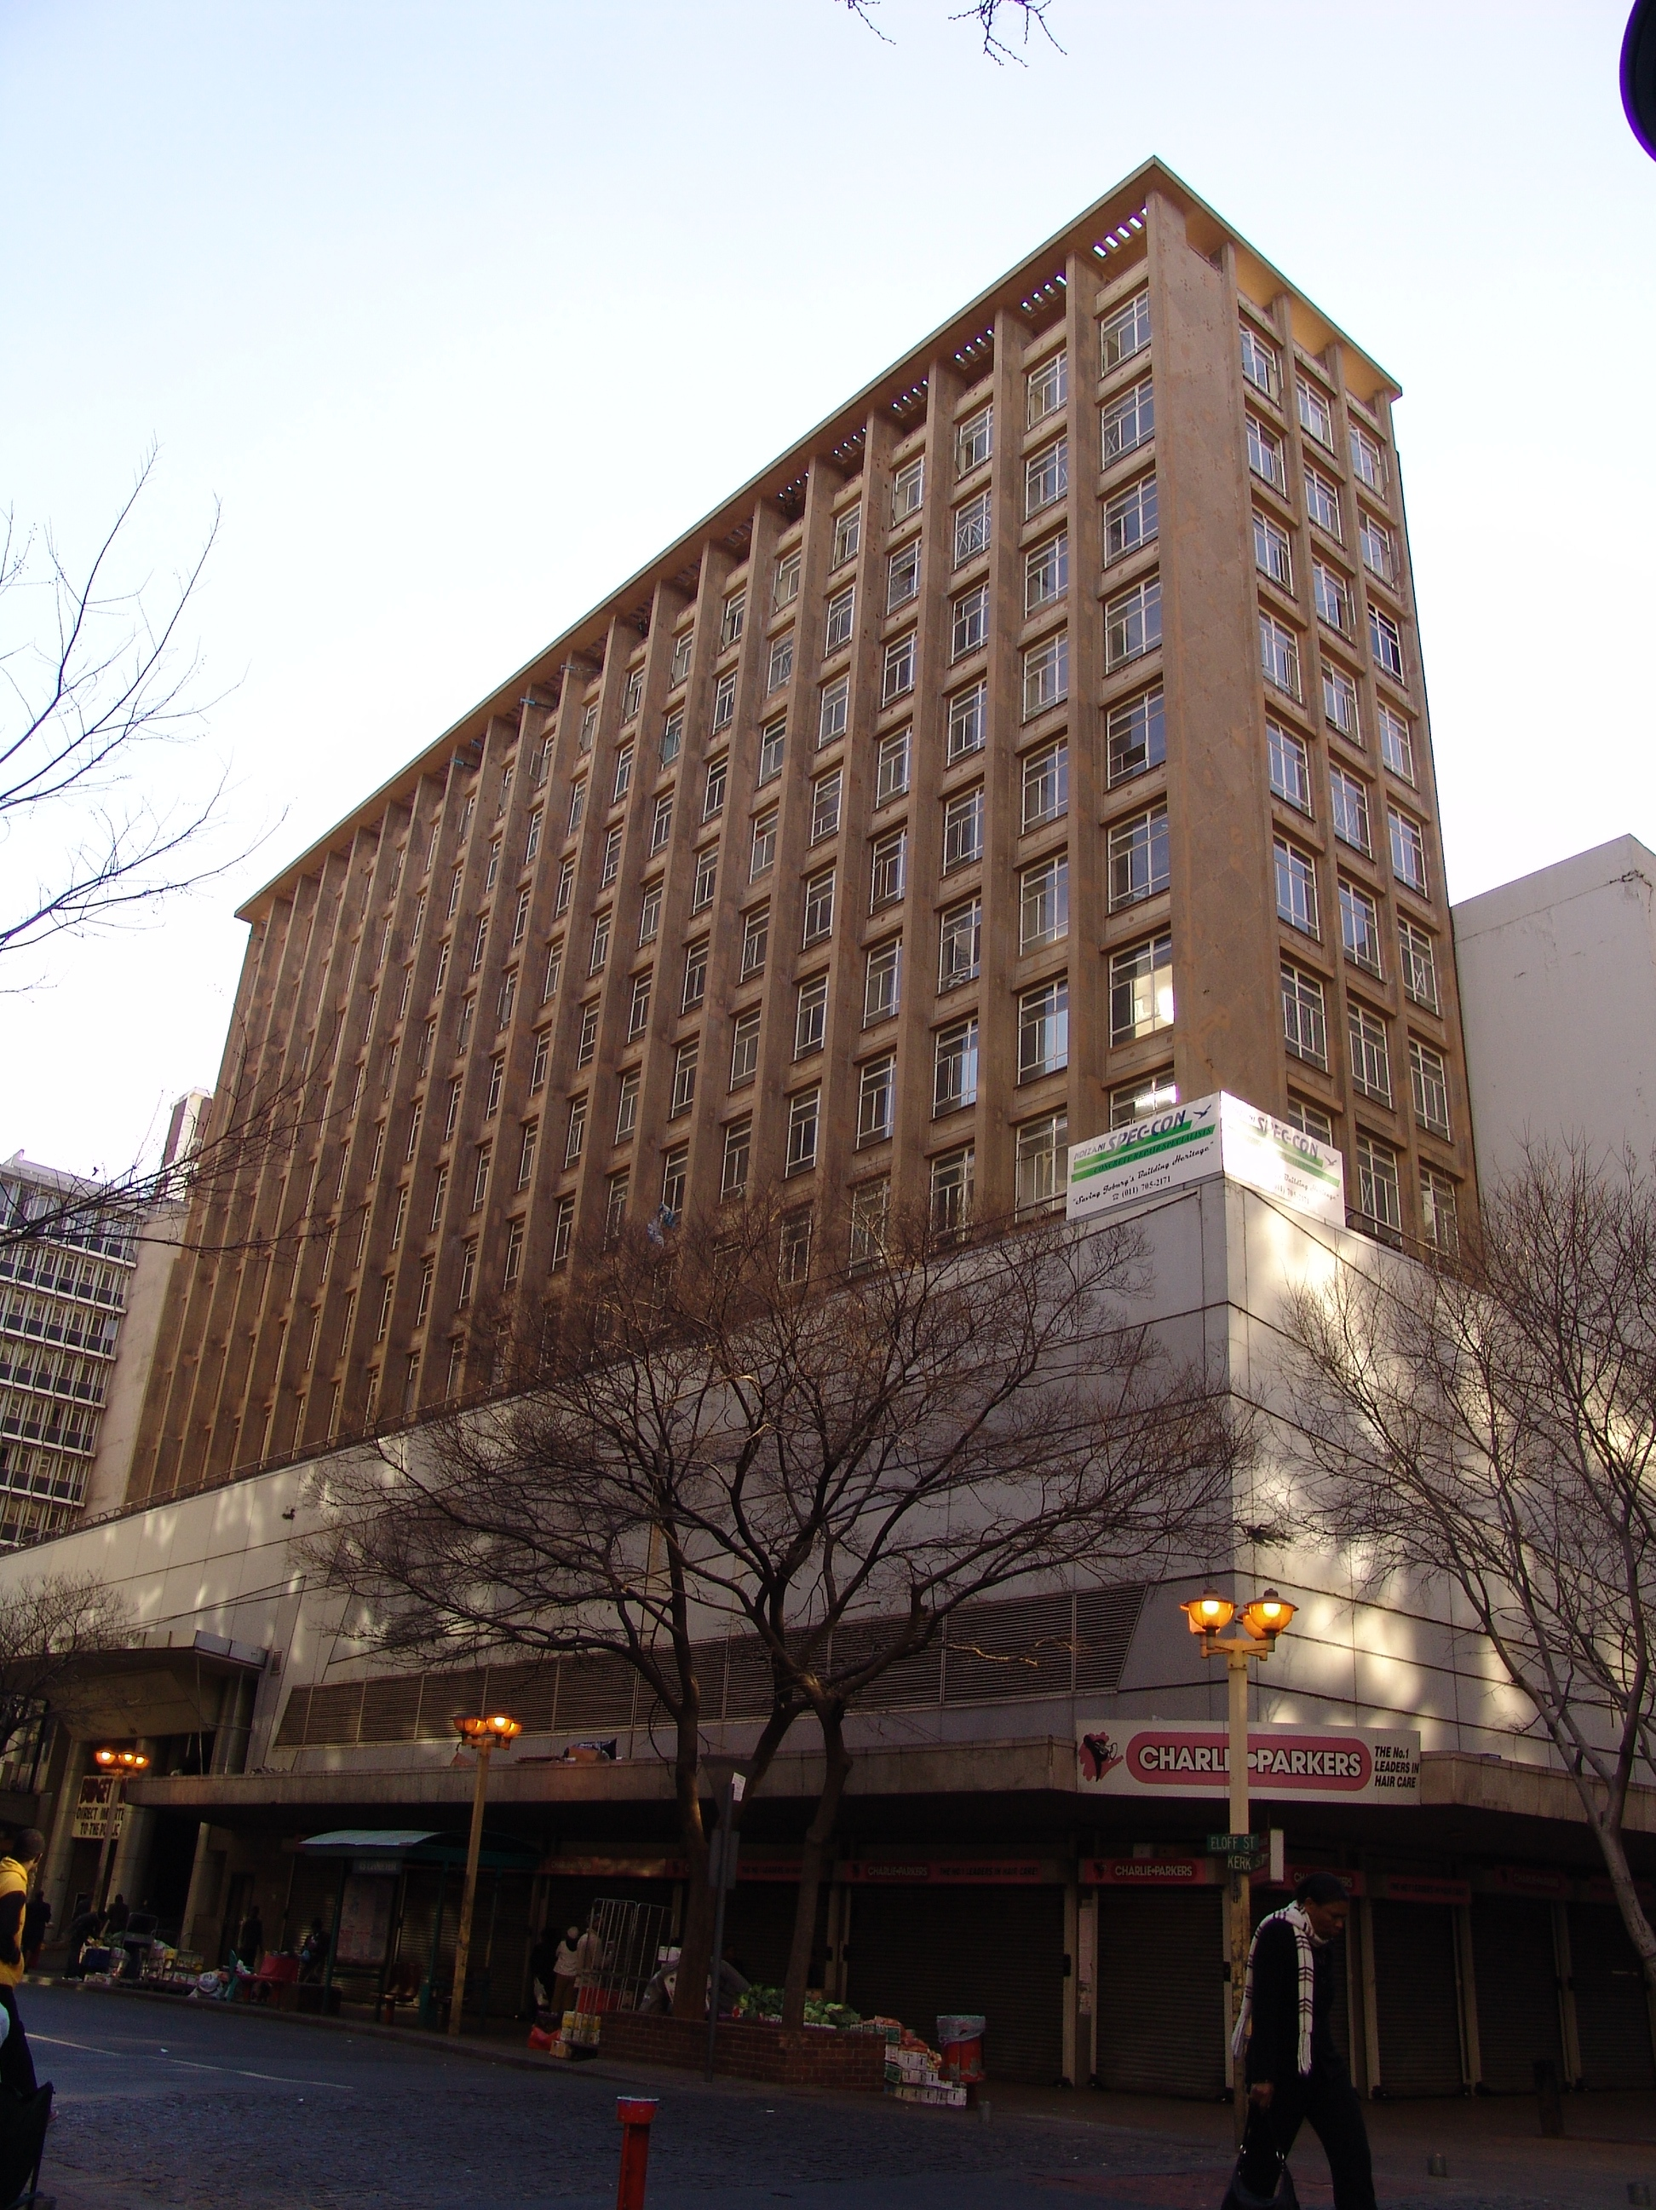

Photograph: Catharina JM Bruwer.

Previous/alternative name/s :
:
:

LOCATION: Street : corners Kerk, Eloff and Jeppe
Street number : 100 Eloff
: (63 Kerk; 94, 96, 98, 100 Eloff; 172, 174 Jeppe)
Stand Number : 4838
Previous Stand Number: 1091, 1092, 1096, 1098
Block number : AU
Suburb : Johannesburg
GIS reference :

ZONING: Current use/s :
Previous use/s :

DESCRIPTION OF PLACE:

Height :
Levels above street level :
Levels below street level :
On-site parking :

“Walter Mansions and Bosman Building as well as African City and Marlborough House were all Eloff Street sites owned by African City Properties, the historic property trust that erected the ACPT Building on Market Square in 1896. in the 1950s this property group was controlled by the Glazer Brothers working tandem with Volkskas and other rising financial interest. Their architects were Obel & Obel but in effect thet were Wayburne & Wayburne, which is the reason why in 1956 there were large name-boards on four major Eloff Street sites bearing the legend: ‘Architects Obel & Obel (in large letters) ‘with Wayburne & Wayburne’ (in small lettering). Marlborough House and African City were completed as Wayburne buildings”. (Chipkin, C.M.: Johannesburg Style; Architecture & Society…).

“Wayburne’s office in Johannesburg, like many others, absorbed the form without the curtain wall, although they didn’t quite get it right at Marlborough House and African City on Eloff Street” (Chipkin, C.M.: Johannesburg Style; Architecture & Society…).

“At some stage after 1957, ACPT switched architects from Wayburne & Wayburne to H. W. E. Stauch & Partners in Pretoria. Thus Stauch inherited the predetermined column grid from a symmetrical tower building on the Bosman site, a layout originally influenced no doubt – like Marlborough House before it – by the Moscow journal Architektura. (Chipkin, C.M.: Johannesburg Style; Architecture & Society…).

CONSTRUCTION MATERIALS:

Walls:

Roof:

Windows:

SITE FEATURES:

ALTERATIONS:

INTEGRITY:

INSCRIPTION:

ARCHITECT:

Israel WAYBURNE
‘…(6 Mar 1905 Aug 1983) was born in Russia and arrived in South Africa in 1910 where he was educated. It is not certain where he received his training although he probably studied at the University of the Witwatersrand. He was a member of the Institute of South African Architects by 1927 and in 1931 joined the staff of African Consolidated Investment Co Ltd as architect to their construction department. How long he stayed in this post is uncertain. He collaborated with GRINKER & SKELLY on a block of flats in Killarney, Johannesburg in 1933 and from 1933 until 1936 several blocks of flats by him have been recorded in central Johannesburg. After 1944 he was in partnership with C Wayburne (d.1957), practising as Wayburne & Wayburne. TPIA 1927; ISAA 1927; MIA; MCQS. (SAAR Dec 1931:127; South African Jewish Year Book 1929:5689 90; ISAA mem list)…’
(Architects In South Africa 1780 – 1940; Draft manuscript, J Walker & G M van der Waal, 1992, HSRC, Pretoria.)

BUILDER:

CONSTRUCTION DATE:

Date on plans :
Approval of plans :
Completion date :

The original plans and relevant Approval of Plans Application Form for the building could not be found.

Below: Reproduced from Chipkin, C.M.: Johannesburg Style; Architecture & Society…

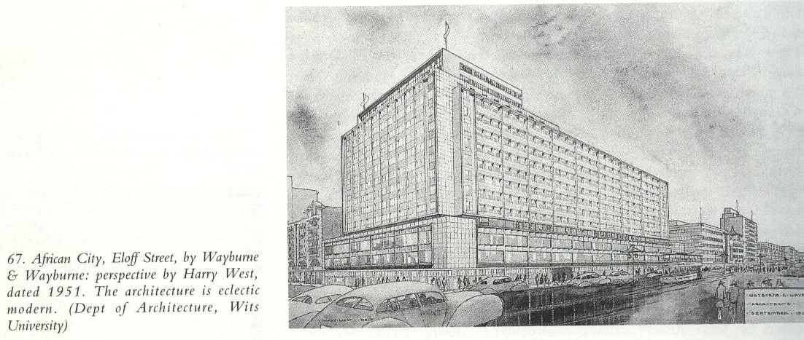
BUILDING STYLE:

Late Modernist. 1950s.

BUILDING TYPE:

Shops to street and office building

ENVIRONMENT:

CONDITION:

URGENT ACTION:

SAHRA RECORD REGARDING ALTERATIONS, RENOVATIONS, RESTORATION:

PROTECTION STATUS: (under National Heritage Resources Act, 1999)

General protection: Section 34(1) structure/s

Formal protection: provincial heritage site

national heritage site

provisional protection

heritage area

listed in provincial heritage
resources register

Relevant Gazette Notice:

Gazette description:

FORMER PROTECTION STATUS: (under National Monuments Act, 1969)

NOTES:

DEEDS INFORMATION:

Original ownership: C B D Kerk Street (Pty) Ltd.
Registration Date: 2002-08-27
Document: T7195/1957
Amount:

Ownership: African City Prop Trust 1952 (Pty) Ltd.
Registration Date: 2002-08-27
Document: T7195/1957
Amount: R NIL

Ownership: Pangbourne Prop Ltd.
Registration Date: 2003-07-31
Document: T54662/2002
Amount: R16000 838.00

Ownership: Apexhi Prop Ltd.
Registration Date: 2003-02-04
Document: T5684/2003
Amount: R24308 146.00

PRE-HISTORY OF SITE:

According to Chipkin: “The original name of Medical City was Walter Mansions, and Walter Mansions and Bosman Building as well as African City and Marlborough House were all Eloff Street sites owned by African City Properties.” (Chipkin, C.M.: Johannesburg Style; Architecture & Society…).

Pollock Mansions

Van der Waal: “the growing wealth of the mining town in the mid 1890s was reflected in more richly embellished cast-iron verandahs, of which the best examples were those of the Heath Hotel (1894-5), Pritchard Street; Estcourt Building (c. 1896), 84/6 Pritchard Street; and Pollock Mansions (c.1897), 94, 96, 98, 100 Eloff Street. The first Castle Mansions (1899-1902), 87,9,91/2, Eloff Street had bay windows instead of verandahs. As in the case of Pollock Mansions, the roofline was interrupted by a row of attractive gables. The façade with its decorative banding was one of the very few examples of the revival of Jacobean architecture in Johannesburg.10 Both Castle Mansion and Pollick Mansions extended over the full width of a block and were worthy predecessors of the flat or apartment complexes that were to rise in Johannesburg later.” (Van Der Waal, G-M.: From Mining Camp to Metropolis…) See also BUILDING STYLE.

TRUST BUILDING

Leck, William (1852 - 9 Aug 1907)
‘…was among the early architects in Johannesburg who had received a solid architectural training in Britain. He was born in Belfast, Northern Ireland, entering a five-year apprenticeship with Francis Stirrat in Belfast in 1870; he worked as an assistant to Thomson & Turnbull. Leck subsequently worked in the offices of John Burnet & Sons in Glasgow and of Fred Wheeler, before going to London to work first for William Young and then for Ernest George & Peto as managing assistant where he met Herbert BAKER who later proposed Leck's FRIBA membership and commented on Leck's works in Johannesburg as being 'of real architectural quality. The best here, quite' (Leck's FRIBA nom papers 1904).
Before coming to South Africa in 1889, Leck travelled for three months on the continent, visiting Paris, Holland and Belgium and studied at the Royal Academy Schools in London.
On his arrival in the Transvaal Republic he opened an office in Pretoria but after a time left for Johannesburg (EJ WELLMAN was employed in Leck's office at this time (1894-1899)). In about 1898 Leck entered into partnership with Frank EMLEY (cf. LECK & EMLEY). In about 1906/1907 GAH DICKSON joined Leck & Emley in partnership (cf. LECK, EMLEY & DICKSON). Leck was resident architect for TH SMITH'S Carlton Hotel (1903-1906).
In 1903 Leck was elected president of the Transvaal Institute of Architects and was a respected figure in professional circles. His professional advice was sought on many occasions. He was consulted, as president of the Society of Architects (South African branch) and as vice-president of the Transvaal Institute of Architects, for his opinion on holding an architectural competition for the proposed Pretoria Post Office. His advice is contained in the correspondence concerning this job.
His sudden death from pneumonia while on a trip to Durban in 1907 was considered a great loss to the profession.
(Architects In South Africa 1780 – 1940; Draft manuscript, J Walker & G M van der Waal, 1992, HSRC, Pretoria’.)

HISTORY:

“The original name of Medical City was Walter Mansions, and Walter Mansions and Bosman Building as well as African City and Marlborough House were all Eloff Street sites owned by African City Properties, the historic property trust that erected the ACPT Building on Market Square in 1896. in the 1950s this property group was controlled by the Glazer Brothers working tandem with Volkskas and other rising financial interest. Their architects were Obel & Obel but in effect thet were Wayburne & Wayburne, which is the reason why in 1956 there were large name-boards on four major Eloff Street sites bearing the legend: ‘Architects Obel & Obel (in large letters) ‘with Wayburne & Wayburne’ (in small lettering). Marlborough House and African City were completed as Wayburne buildings”. (Chipkin, C.M.: Johannesburg Style; Architecture & Society…)

“Wayburne’s office in Johannesburg, like many others, absorbed the form without the curtain wall, although they didn’t quite get it right at Marlborough House and African City on Eloff Street”.
(Chipkin, C.M.: Johannesburg Style; Architecture & Society…)

GENERAL NOTES:

Estimated cost of building :
Estimated cost of drainage :
Accommodation approved :
Valuation at completion :
Occupied :

PREVIOUS TENANT/S:
By 1954:
Eloff - Edgars; Woolworths; Central News Agency (CNA).
Goldies (coffee and milk bar).
100 Eloff - S. H. Matz, “Creations, ladies’ wear…”
100 Eloff - Barlow’s Electrical Department Ltd. “Kelvinator refrigerators, Moffates ranges and electrical appliances. Office and showrooms…”
96 Eloff – Eddies Fruit Market
96a Eloff – Geneva Watch Co.
172 Jeppe – Teffner et Cie (milliners).
174 Jeppe – The Piccadilly Bar.
(The Rand-Pretoria Directory 1954 (Comprising Complete Alphabetical And Trades Directories of Johannesburg, Pretoria And Reef Towns), Cape Times Limited, Cape Town, 1954.)

CURRENT TENANT/S:

Charlie Parkers
Spe-Con (Concrete Repair Specialist)
Budget Shop (Direct Importer to the Public)
Jet Mart – Clothing Shop

SOURCES:

Published Sources
Chipkin, C.M.: Johannesburg Style; Architecture & Society 1880s – 1960s, David Philip Publishers, Cape Town, 1993.
The Rand-Pretoria Directory 1954 (Comprising Complete Alphabetical And Trades Directories of Johannesburg, Pretoria And Reef Towns), Cape Times Limited, Cape Town, 1954.
Van Der Waal, G-M.: From Mining Camp to Metropolis, The buildings of Johannesburg 1886-1940, Chris Van Rensburg Publications, Johannesburg, 1987.

Unpublished Sources
Architects In South Africa 1780 – 1940; Draft manuscript, J Walker & G M van der Waal, 1992, HSRC, Pretoria.
Johannesburg Building, Space & Urban Feature Classification, 1998: Inner City - Metropolitan Planning, Johannesburg Metropolitan Council (Cool Factory).
Plans records of surveyed buildings, Marshallstown and City of Johannesburg: Archives, Building Control, Development Management, City of Johannesburg Metropolitan Municipality.
Rand Township Registry Johannesburg.

ASSESSMENT OF CULTURAL SIGNIFICANCE:

Historic Value:

Associated with historic person, group or organisation

Associated with historic event or activity

Architectural/Aesthetic value:

Important example of building type

Important example of a style or period

Fine details, workmanship or aesthetics

Work of a major architect or builder

Social/Spiritual/Linguistic value:

Associated with social, spiritual, linguistic, economic or political activity

Illustrates an historical period

Scientific/Technological value:

Example of industrial, technical or engineering development/achievement

New, rare or experimental building techniques

RECORDED BY:


Heritage Resources Management team Johann J Bruwer and Alezea Bruwer.

And Catharina JM Bruwer.

Photographs (unless otherwise indicated) by Johann J Bruwer and Alezea Bruwer.

