CATALOGUE NO: AT-3 DATE RECORDED: JANUARY – JUNE 2006
__________________________________________________________________

JOHANNESBURG METROPOLITAN MUNICIPALITY

HERITAGE ASSESSMENT SURVEYING FORM
__________________________________________________________________

Compiled by: Dr JJ Bruwer, 2002-07-29 JJ Bruwer ©
Cellphone: +27 82 325 5823

NAME OF PLACE: EDINBURGH COURT

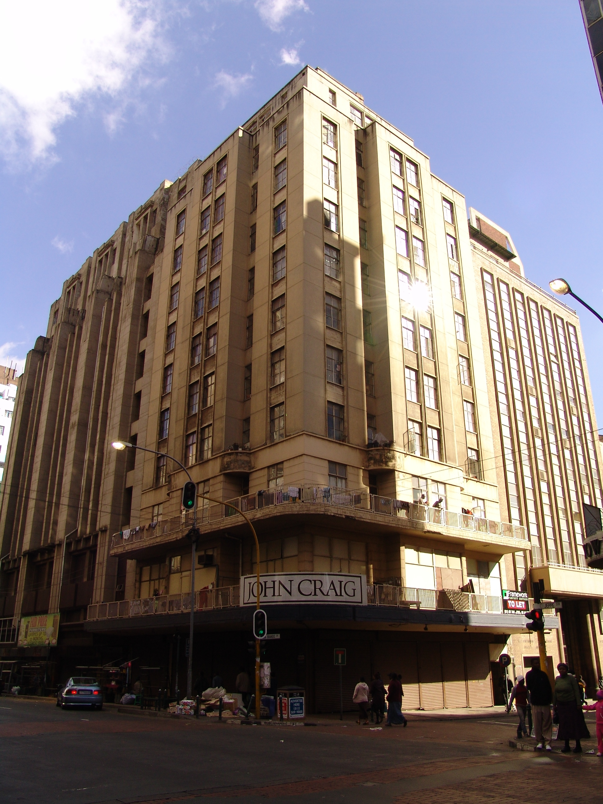

Photograph: Catharina JM Bruwer.

Above: Edinburgh Court to centre of the photograph with Essanby House (AT-2) to the left and Johannesburg Coronation Dental Infirmary Building (AT-4) to the right. (CJMB)

Previous/alternative name/s : John Craig
:
:

LOCATION: Street : corner Jeppe and Von Brandis
Street number :
: (177 Jeppe; 79 Von Brandis)
Stand Number : 1275
Previous Stand Number: 1145
Block number : AT
Suburb : Johannesburg
GIS reference :

ZONING: Current use/s :
Previous use/s :

DESCRIPTION OF PLACE:

Height : 151’ 6”
Levels above street level : 13
Levels below street level : one (storage)
On-site parking :

An excellently designed corner building.

Ground and First Floor are double volume floors.

See electronic version of Survey Report for copies of the original building plans.
(CJMB)

CONSTRUCTION MATERIALS:

Foundation: reinforced concrete (11” deep)

External walls: brick, burnt stock blues; terrazzo cladding

Internal walls: brick, burnt stock blues

Mortar: mortar in walls composed of sand and lime

Damp course: asphalted sheeting

Roof: asphalted sheeting

Windows: steel frame

Floor:-

Basement: sika grano concrete (5” deep)

Other: wood block floor on concrete slab

Drainage:-

Sewage drains: cast iron

Soil pipes: cast iron

Waste pipes: wrot iron

Ventilation shafts: cast iron and wrot iron

This is a reinforced concrete structure.
(CJMB)

SITE FEATURES:

ALTERATIONS:

Various alteration plans are available. (CJMB)

INTEGRITY:

The integrity of the building as seen from the exterior appears to be intact. (CJMB)

INSCRIPTION:

ARCHITECT:

Kallenbach, Kennedy & Furner. A. R. I. B. A.
(Johannesburg, Durban, Pretoria & Cape Town)
(Address: 72 Sackes Building, Joubert Street, Johannesburg)
‘…The partnership between H KALLENBACH, AM KENNEDY and AS FURNER in Johannesburg from 1928. Late in 1928 Furner resigned his post as lecturer at the School of Architecture at the University of the Witwatersrand and joined Kallenbach and Kennedy as a junior partner. The firm built up an extensive practice throughout South Africa. According to Herbert (1975:48), 'the predominant influence in...the office was undoubtedly Teutonic' which Herbert attributes to both Kallenbach's origins and Furner's admiration of German and Austrian architects. There were also two Austrian draughtsmen in the office, Fritz BERGE and Werner WAGNER, who assisted in the design of the Plaza Cinema and who surely added to this influence. According to Wagner (1990), Kallenbach was the head of the office and saw that work came in; Kennedy was the technical man and Furner the architect. The 1930s were a productive era for the partnership, the boom in the economy coinciding with Furner's arrival; Furner has been credited with the new and more modern image of the firm. In the Rand Daily Mail Exhibition (1934) the firm was responsible for transforming the Hall of Transport into an 'Ideal Village.'
Many South African architects worked at one time or other in the office of Kallenbach, Kennedy & Furner. Among these were TO DUNCAN (around 1934); CR FRIDJHON (in Durban from around 1931), BS COOKE (part-time from 1928 to 1931, W Wagner and Fritz Berge. In about 1929 RD MARTIENSSEN worked there briefly. The early records of the office of Kallenbach, Kennedy & Furner have not been kept…’
(Architects In South Africa 1780 – 1940; Draft manuscript, J Walker & G M van der Waal, 1992, HSRC, Pretoria.)

BUILDER:

CONSTRUCTION DATE:

Date on plans : 29 January 1935
Approval of plans : 17 June 1935
Completion date : 20 May 1936
(CJMB)

BUILDING STYLE:

Art Deco. 1930s

BUILDING TYPE:

Shops to street and residential building.

The building was designed as an office, warehouse and domestic building.
(CJMB)

ENVIRONMENT:

The area surrounding the building is neglected and forgotten by the owners and the fathers of the city. This neglected building impacts negatively on the image of the City of Johannesburg as it is in the vicinity of the Johannesburg Supreme Court, which receives regular media attention.
(CJMB)

CONDITION:

This once proud building is in a neglected condition and requires attention.
(CJMB)

URGENT ACTION:

City grime has taken its toll and the lack of maintenance to the building, is jeopardizing the stucco work to the main façade.
(CJMB)

SAHRA RECORD REGARDING ALTERATIONS, RENOVATIONS, RESTORATION:

PROTECTION STATUS: (under National Heritage Resources Act, 1999)

General protection: Section 34(1) structure/s

Formal protection: provincial heritage site

national heritage site

provisional protection

heritage area

listed in provincial heritage
resources register

Relevant Gazette Notice:

Gazette description:

FORMER PROTECTION STATUS: (under National Monuments Act, 1969)

NOTES:

DEEDS INFORMATION:

Original ownership: “E & D” (Pty.) Ltd.
102 Commissioner Street, Johannesburg.

Ownership: Jankay (Pty) Ltd.
Document: T27683/1980
Amount:

PRE-HISTORY OF SITE:

HISTORY:

GENERAL NOTES:

Estimated cost of building : £35 000.00
Estimated cost of drainage : £2 500.00
Accommodation approved : 40 ‘Europeans’
: 7 ‘Natives’
Valuation at completion : £27 000.00
Occupied : yes
(CJMB)

PREVIOUS TENANT/S:

By 1954:
177 Jeppe – Bermeisters “W. Bermeisters (Pty) Ltd…For All Leading Makes of Radios, Cameras, Photographic Equipment and Electrical Goods…”
177 Jeppe – Maurice Tatz, gent’s outfitter (home address – 7, Tenth Ave, Lower Houghton).
79 Von Brandis – Karnos Opticians. (The Rand-Pretoria Directory 1954)
(CJMB)

CURRENT TENANT/S:

SOURCES:

Published Sources
The Rand-Pretoria Directory 1954 (Comprising Complete Alphabetical And Trades Directories of Johannesburg, Pretoria And Reef Towns), Cape Times Limited, Cape Town, 1954.

Unpublished Sources
Architects In South Africa 1780 – 1940; Draft manuscript, J Walker & G M van der Waal, 1992, HSRC, Pretoria.
Johannesburg Building, Space & Urban Feature Classification, 1998: Inner City - Metropolitan Planning, Johannesburg Metropolitan Council (Cool Factory).
Plans records of surveyed buildings, Marshallstown and City of Johannesburg: Archives, Building Control, Development Management, City of Johannesburg Metropolitan Municipality.
Rand Township Registry Johannesburg.

ASSESSMENT OF CULTURAL SIGNIFICANCE:

Historic Value:

Associated with historic person, group or organisation

Associated with historic event or activity

Architectural/Aesthetic value:

Important example of building type

Important example of a style or period

Fine details, workmanship or aesthetics

Work of a major architect or builder

Social/Spiritual/Linguistic value:

Associated with social, spiritual, linguistic, economic or political activity

Illustrates an historical period

Scientific/Technological value:

Example of industrial, technical or engineering development/achievement

New, rare or experimental building techniques

RECORDED BY:


Heritage Resources Management team Johann J Bruwer and Alezea Bruwer.

And Catharina JM Bruwer.

Photographs (unless otherwise indicated) by Johann J Bruwer and Alezea Bruwer.

