+===CATALOGUE NO: AT-2 DATE RECORDED: JANUARY – JUNE 2006
__________________________________________________________________

JOHANNESBURG METROPOLITAN MUNICIPALITY

HERITAGE ASSESSMENT SURVEYING FORM
__________________________________________________________________

Compiled by: Dr JJ Bruwer, 2002-07-29 JJ Bruwer ©
Cellphone: +27 82 325 5823

NAME OF PLACE: ESSANBY HOUSE

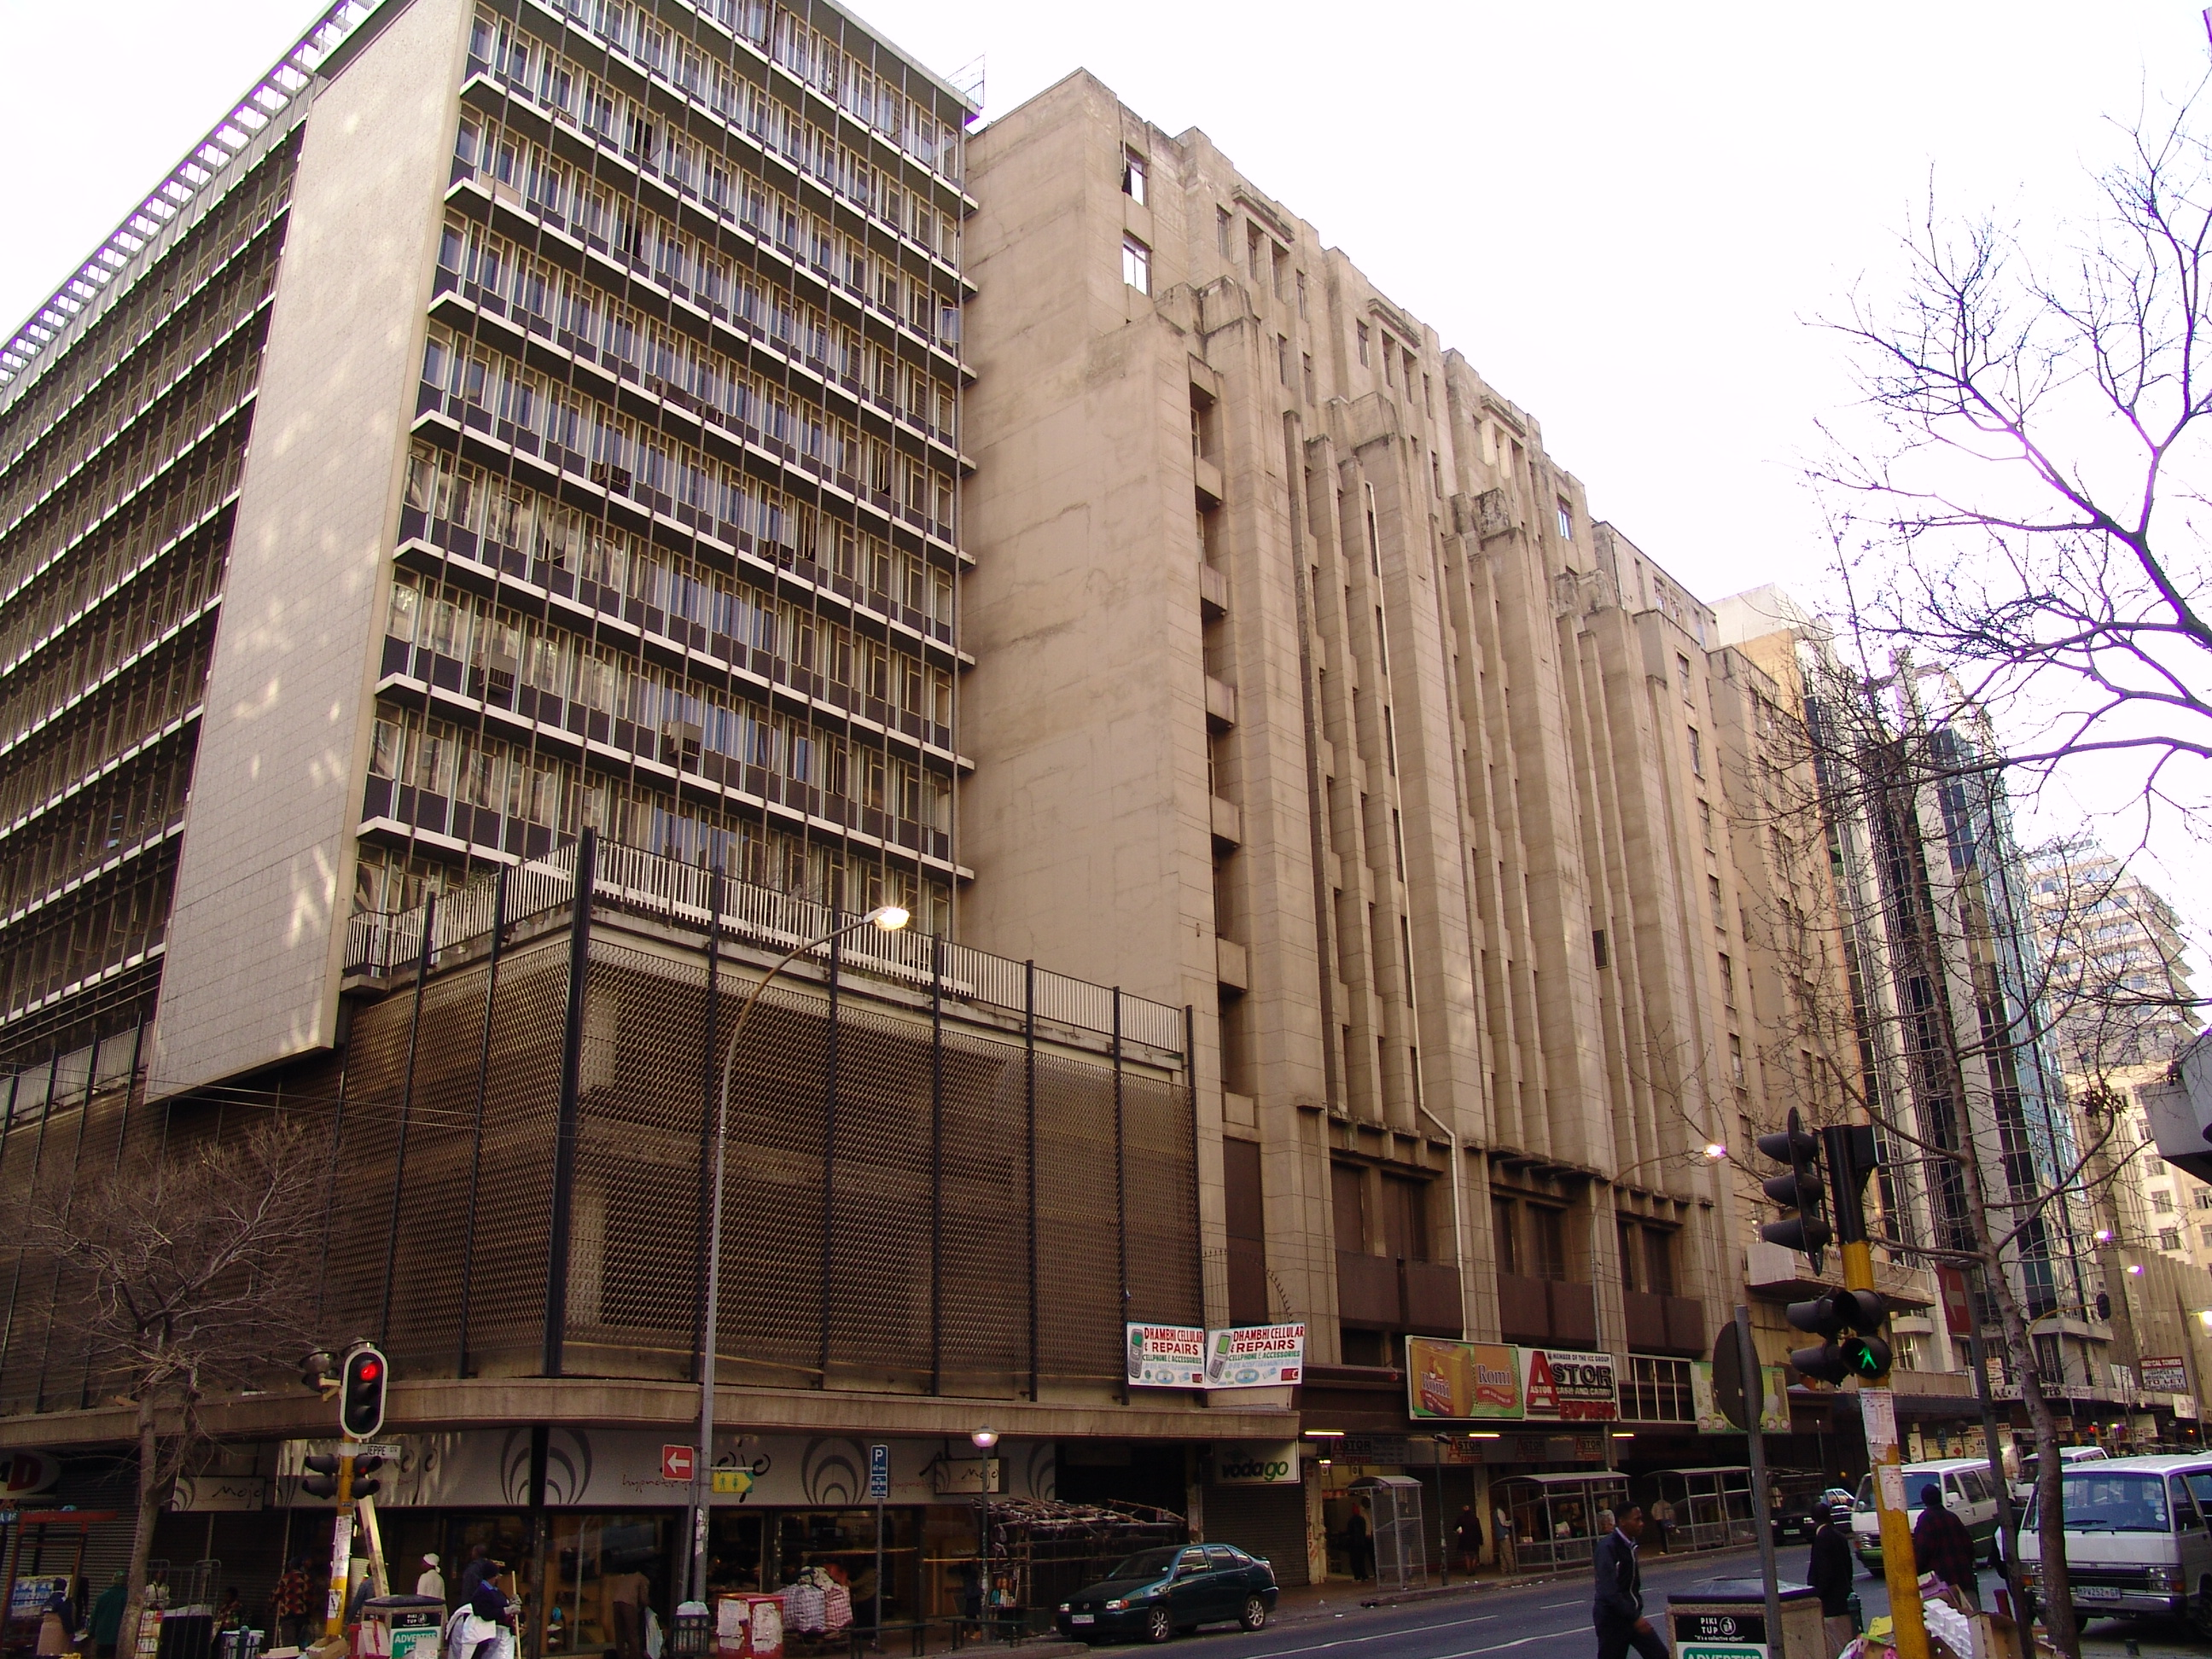

Photograph: Catharina JM Bruwer.

Above: Essanby House to the centre of the photograph, with Medical City (AT-1) to its left, and the Jeppe Street façade of Edinburgh Court (AT-3) to the right. (CJMB)

Previous/alternative name/s : Shepherd & Barker shop
:
:

LOCATION: Street : Jeppe
Street number : 173
: (173, 175 Jeppe)
Stand Number : 5187
Previous Stand Number: 1273, 1274
Block number : AT
Suburb : Johannesburg
GIS reference :

ZONING: Current use/s :
Previous use/s :

DESCRIPTION OF PLACE:

Height :
Levels above street level :
Levels below street level :
On-site parking :

This is a magnificent building and strongly reminiscent of Castle Mansions (AE-2). (CJMB)

“…the articulated cantilever stairs and the courtyard-like open space of the Shepherd & Barker shop in Essanby House (1938), 173/5 Jeppe Street, was an unusually successful example of the use of diagonal focus lines in a space extending over four storeys. The severe vertical lines of the façade texture did not betray the dynamic spatial articulation of the interior of the shop.” (Van Der Waal, G-M.: From Mining Camp to Metropolis…)

The original plans and associated Approval of Plans Application Form for the building could not be found.

CONSTRUCTION MATERIALS:

Walls:

Roof:

Windows:

SITE FEATURES:

ALTERATIONS:

INTEGRITY:

INSCRIPTION:

ARCHITECT:

Frederick Williamson
‘…(c1890 1945), born in England, Williamson was articled to WJ Lindsay Grant, Manchester, from 23 December 1908 where he remained until 23 December 1911, attending courses in design amd construction at the Manchester School of Technology and School of Architecture. From 1912 to 1914 he attended part day and evening courses at the Liverpool School of Architecture and on completion of articles he was employed by WJ Collins in Liverpool. He enlisted during the First World War and served with the Royal Navy in Minesweepers from 1914 to 1918. After the war he travelled in France, Italy and Greece and visited Constantinople between 1918 and 1919; he was exempted from the final RIBA examination under the special war concession but returned to Liverpool and attended architectural courses under Professor Reilly who signed Williamson's RIBA papers (1920) noting: >a good and hard working student with good abilities. In 1920 Williamson spent a few months working with Reilly's preferred American architects, McKim, Mead & White, in New York.
In 1920 he came to South Africa and joined Frank EMLEY in partnership (cf. EMLEY & WILLIAMSON). Emley had recently won the competition for the main buildings at the University of the Witwatersrand. Owing to EMLEY's poor health, Williamson took over much of the responsiblity of the firm's work, seeing to the execution of the Main University Building in association with COWIN & POWERS. According to his obituary in the South African Architectural Record Williamson was the one who was chiefly responsible for the introduction of cast concrete facing blocks which were used for the first time in Johannesburg in the University buildings.
From 1921 until 1925 Williamson lectured part time in architectural design at the School of Architecture at the University of the Witwatersrand and was later one of the senior examiners there. GE PEARSE noted Williamson's >loveable, though at times ... aggressive dogmatic disposition, so characteristic of the Navy (SAAR Jan 1946:28). Williamson contracted malaria in 1932 and nearly died in Rustenburg Hospital. In the 1930s he was principally occupied with ongoing building at the University of the Witwatersrand, among the works at the time were the William Cullen library (1933 34), the Bernard Price Institute (1935) and the Wolf Hillman Engineering block (1939), in association with Cowin & Powers and other architects. According to Pearse, Williamson's early work in Johannesburg reflects the influence of the Liverpool School of Architecture and his American experience, both based on the study of classical architecture and that of the Italian Renaissance. This is evidenced by the University buildings but again the choice of style was conventional and preferred by the University Building Committee. It is interesting to compare the work with the contemporary Cape Town University buildings. Domestic work carried out by Williamson during the 1920s and 1930s was in the popular Spanish Mission style.
Elected Vice Chairman of the Federal Council on Architectural Education; Editor of the SAAR in 1926; member of Council of ATA and TIA; President TPIA 1928; Vice President in Chief ISAA 1933 34; MCQS; ARIBA 1920; ISAA 1927. (ARIBA nom papers (1920)…’
(Architects In South Africa 1780 – 1940; Draft manuscript, J Walker & G M van der Waal, 1992, HSRC, Pretoria.)

BUILDER:

CONSTRUCTION DATE:

Date on plans :
Approval of plans :
Completion date :

The original plans and associated Approval of Plans Application Form for the building could not be found.

BUILDING STYLE:

Art Deco – Monolithic. 1940s.

Architectural Merit: “One of the grand Art Deco buildings of Johannesburg.”
(Johannesburg Building, Space & Urban Feature Classification, 1998: Inner City).

BUILDING TYPE:

This is a shop to street and office building. (CJMB)

ENVIRONMENT:

The area surrounding the building is neglected and forgotten by the owners and the fathers of the city. This neglected building impacts negatively on the image of the City of Johannesburg as it is in the vicinity of the Johannesburg Supreme Court which receives regular media attention. (CJMB)

CONDITION:

This building stands vacant from First Floor up; the owners have removed the name of the building and seem not to have any intention of maintaining the exterior façade as this is slowly rotting away. (CJMB)

URGENT ACTION:

The owners should be requested to reinstate the name of the building and to do basic maintenance work in order to prevent further damage to the stucco work. (CJMB)

SAHRA RECORD REGARDING ALTERATIONS, RENOVATIONS, RESTORATION:

PROTECTION STATUS: (under National Heritage Resources Act, 1999)

General protection: Section 34(1) structure/s

Formal protection: provincial heritage site

national heritage site

provisional protection

heritage area

listed in provincial heritage
resources register

Relevant Gazette Notice:

Gazette description:

FORMER PROTECTION STATUS: (under National Monuments Act, 1969)

NOTES:

DEEDS INFORMATION:

Ownership: 175 Jeppe Street Share Block CCT
Document: T33553/1984
Amount:

Ownership: Essenby Inv. (Pty) Ltd.
Document: T37791/1992
Amount:

Ownership: Aqueous Share Block (Pty) Ltd.
Document: T5689/2003
Amount: R5529 000.00

PRE-HISTORY OF SITE:

HISTORY:

‘Winnie Suspended As PWV Regional Chairperson
JOHANNESBURG May 24 Sapa
Mrs Winnie Mandela was on Sunday ousted from her power base within the ANC Women's League following a heated PWV inter-branch meeting in Johannesburg as controversy surrounding her mounted at the weekend.
According to sources who attended the meeting, the recently appointed Regional Executive Committee (REC) of the ANCWL PWV region was suspended until further notice, effectively removing Mrs Mandela from her position of power within the organization as PWV chairman.
"I really know nothing about this," a surprised Mrs Mandela told Sapa on Sunday night. "I will comment when I get a statement."
Although Mrs Mandela was not specifically referred to in this connection at the meeting, one source, who asked not to be named, said: "It was all about Winnie ... it is a concerted effort to
clip her wings."
An official statement on the latest developments surrounding the militant Mrs Mandela is expected on Monday from the ANC.
In recent weeks Mrs Mandela was separated from her husband, ANC president Nelson Mandela, was pressured into resigning as head of the welfare department, and a series of allegations involving her in criminal and financial irregularities which have severely embarrased the organisation.
Sunday's meeting at Essenby House -- the PWV region's headquarters -- was in part a sequel to last Thursday's demonstration where about 40 women demanded Mrs Mandela's resinstatement as welfare head.’
(http://64.233.183.104/search?q=cache:Knb5tlnhgOsJ:www.anc.org.za/anc/newsbrief/1992/news9205.25+%22essenby+House%22+%22johannesburg%22&hl=en)

‘VIOLENT INCIDENTS IN CENTRAL Johannesburg\ANC Media Statement About the Incidents in Central Johannesburg
28th March 1994.
The Central business District of Johannesburg today, 28th March 1994, was the scene of terrible tragedy. A large number of people were killed and scores have been injured in bloodletting that could easily have been avoided.
The African National Congress extends its condolences to the families that have bereaved as a consequence of today's events. Our best wishes for a speedy recovery also to the injured.
According to the information presently at our disposal the course of events was as follows. A rally, to take place at the Library Gardens between President and Market Streets in Central Johannesburg, was called by the Inkatha Freedom Party for this morning. The ANC received indications on Sunday 27th March that the rally would be accompanied by an armed demonstration which would target our regional offices on Jeppe Street and our national offices at Plein Street. The PWV regional Commissioner of Police was informed and a formal request was made that requisite security measure be taken to minimise the possibilities of violence. Police Commissioner Johan van de Merwe was contacted on Sunday 27th March and advised of the dangers and he undertook to ensure that adequate measures were taken to protect life and property.
At about 08.30 hours, Comrade Penuel Maduna, a Member of the National Executive Committee of the ANC, was fired on by a crowd of IFP supporters as he was driving to work. He fortunately was able to evade his attackers and escaped unscathed. On arrival in his Office at Shell House, he telephoned Comrade Cyril Ramaphosa, advising him of the attack and requesting that he contact the Commissioner of Police.
Beginning at 07.30 hours, armed demonstrators, some carrying firearms, began parading through the streets of Central Johannesburg. This march was being coordinated by Messrs Themba Khoza, recently implicated by the Goldstone Commission as a key figure in gun smuggling operations for the benefit of the IFP, and Humphrey Ndlovu, a regional IFP leader.
At around 08.10 hours the armed demonstration passed by the ANC Regional office on Jeppe Street, marching from east to west. Pedestrians an~ other people not involved in the march were being assaulted with sticks and clubs and some fled intro the ANC offices. Despite our earlier requests to the SAP, no police had been deployed to protect the building at that time. ANC security personnel on duty at the regional office were compelled to fire warning shots in the air. It appears that at least one person was injured during this incident. Shortly thereafter the Police entered the building with a view to ascertaining what arms the ANC security personnel had. The officials of the ANC assured them that all the guns in our possession were licensed shotguns. The Police withdrew leaving no visible presence to protect the ANC premises or to monitor the situation.
At 09.14 the armed IFP demonstration appeared from the direction of Von Welligh Street and attempted to enter the general. at Essanby House where the ANC Regional Offices are located. ANC security personnel once again repelled them by firing warning shots. At the same time, Comrade Paul Mashatile, the ANC's secretary for the PWV region, telephoned General Callitz of the SAP to advise of developments at the regional office. general Callitz undertook to deploy personnel on Street to deter further attacks. We have been unable to determine whether anyone was injured during this second incident.
At 12.55 there was firing on windows of offices of the PWV region. ANC security personnel returned the fire. No one was injured as far as we can determine.
At around 09.30 Comrade Joe Nhlanhla, was in telephonic contact with General Beukes of the SAP in Pretoria requesting that urgent action be taken to secure the ANC's Offices in Johannesburg. He specifically requested that approaches to the ANC Head Office on Plein Street be cordoned off and that police be deployed to secure the building. General Beukes undertook to take the necessary measures. Ten Police officers, under the command of a Sergeant, were duly deployed at Shell House at around 10.15.
At around 11.20 the armed IFP demonstration approached Shell House from the west. At the head of their column was an man armed with an AK 47 assault rifle. ANC Security personnel requested the Police on duty to try to divert the march away from Shell House. As the marchers reached the intersection of Wanderers and Plein Street, a section was seen to break- away in the direction of De Villiers Street. The rest proceeded towards Shell House.On reaching the block between King George and Klein Streets, the marchers assembled on the pavement opposite the ANC building and advanced towards it, arms in hand. The ANC's security personnel fired warning shots and the advancing armed group retreated. At that moment a large contingent of armed men, led by one carrying an AK 47 assault rifle, appeared adjacent to the ANC building from the direction of King George street, firing as they came. The ANC's security personnel once again fired warning shots and the advancing group retreated.
It would appear that at this point the Police officers on duty withdrew because not one was visible after for the following 30 minutes. Shots~ evidently from automatic weapons, were heard from the direction of King George Street and a group of armed men advanced from around the same corner to be joined by another from across the street with the obvious intent of storming the ANC Head Office. The ANC's Security personnel then fired into the advancing groups, inflicting a number of casualties. The groups broke up and those that were able to fled down King George and Plein Streets.
Shortly after this shooting incident other participants in the IFP march returned and retrieved the weapons of their injured comrades. This was done in full view of Police officers who now returned to the scene. ANC
Security personnel also reported that two mini-buses, one located on De Villiers Street, another at Wanderers, were unloading automatic weapons and handing these to IFP demonstrators.
The ANC deeply regrets the shootings that occurred. Our security personnel behaved with impeccable forbearance and patience in the face of extreme provocation, firing only when their lives were threatened. Those who must bear full responsibility for the violence and loss of life today, are the regional leaders of the IFP who orchestrated the demonstration and incited the violence. A rally billed to take place at the Library Gardens had as its chief focus not the announced venue, but rather the offices of the ANC ill the PWV region and its Head Office.
Equally blameworthy are the SAP, especially its regional Commissioner and the officers serving under his command. The ANC made every conceivable effort to obtain adequate policing measures around its premises from the earliest hours of today in order to avert clashes and to avoid any loss of life What is puzzling is the complacent attitude of the Police who refused to cordon off streets or divert armed demonstrators away from possible flash points.
The African National Congress is of the view that these incidents are not fortuitous. They are part of a general campaign to destabilise the PWV region and to revive the climate of terror and violence that plagued this region over the past four years. The purposes of its perpetrators are crystal clear - to make it impossible to hold free and fair elections which will clearly demonstrate whom the people of South Africa want as their government.
The timing of this fresh campaign of violence, so shortly after the exposure of the Third Force, is also uncanny. The prominent role played in all these by regional leaders of the IFP cannot be seen as accidental. The spoilers and the purveyors of violence shall not be permitted to thwart the people's struggle for democracy.’
Issued by: The Department of Information and Publicity, P O. Box 61884, Marshalltown 2107
(http://www.anc.org.za/ancdocs/pr/1994/pr0328b.html)

‘South Africa
September 2005
Foreign interest in Jo’burg inner city, (Business Day, 2005-09-30):-Fifteen buildings were sold on Tuesday for R40m at Sandton's Auction Alliance sale, which attracted buyers from New York and Switzerland. The auction started slowly and the first offering, the Tikewele building in Davies Street, Doornfontein, was knocked down for R200000 after desultory bidding. The sale was described by auctioneer Rael Levitt as "the cheapie of the day". He said in a few years' time people will laugh that substantial buildings in the city's central business district could be snapped up so cheaply. Bidding picked up after that, and the multistorey Bree Chambers received an opening bid of R2m, moving up rapidly to R5,1m, a price Levitt said was good but "not great". The modernistic Atkinson House at the corner of Eloff and Albert streets in the Johannesburg city centre drew an opening bid of R2m and was knocked down for a "light" price of R2,7m. It was bought by property developer Dimitri Vagis, who said he would convert the building into residential units for permanent residents and would not consider catering for the temporary accommodation needs of the 2010 Soccer World Cup. The 10-storey Essanby House, a long-standing landmark in Jeppe Street, turned out not to be the bargain it promised to be. Levitt called for an opening bid of R8m, which during his auctioneer's chant was somehow converted into R8000. Once the buyers had had their moment of fun, serious bidding began at R2m and moved up rapidly, albeit in small multiples, to the R2,525m hammer price. "It is a good price and I'm pretty happy with it," said Levitt. The building formerly housed Birnam College, and in its heyday it was one of the stately blocks of flats in an area that included architecturally interesting buildings such as Ansteys Mansions and the Art Deco block of flats that resembles the Chrysler Building in New York. It was bought by a buyer from New York, who says central Johannesburg real estate offers good residential and retail potential in certain areas, and prices are reasonable. He plans to convert Essanby House into residential units, which will be "trendy, functional, fashionable" and aimed at the lower middle class. Walter Ostermeier, from Switzerland, was another foreign bidder at the auction. Though he did not buy, he wants to provide upmarket accommodation for the 2010 Soccer World Cup. "SA needs a city apart from Cape Town for the tournament, and Johannesburg will be cleaned up for the occasion. Once this happens, the city will be greatly improved and offer good investments in property. "I have not bought anything today but will do so at the next two auctions this year." The Ridge Hotel in Abel Road, Berea, attracted keen bidding. It started off as the four-star Golden Crest built during the Tollman hotel empire era in the 1970s. The Tollman family built some of the leading hotels in Gauteng at the time, including Tollman Towers and the Tollman Airport Hotel. At its peak, the Golden Crest was known for the popular Jockey Club cocktail bar, with its resident pianist, as well as the fashionable restaurant and night club on the top floor, where members of Johannesburg's high society, such as the late Harry Oppenheimer, could be seen. It sold for R4,35m, which Levitt said was "brilliant". The odd offering was a stand in the 2600ha Lissataba Game Reserve in the Lowveld. Auctioneer Joff van Reenen added humour by offering "to throw an elephant in for free". A new bidder came in at that stage with an offer of R850000, which gave new impetus to the process, and in the end it fetched R900000. Bidding for the Rynfield Shopping Centre in Benoni turned into a cliffhanger, which provided the most excitement for the day, earning the buyer the loudest round of applause. Bidding was teetering on the brink of the R10m mark when Levitt called for a bid of R10m "to blow out" the last bidder. The blowout came, but at an unhurried pace as bids progressed from R9,7m through R9,75m, R9,8m, R9,85m and R9,9m to R9,925m, just before the magical R10m was reached. The auction ended on an unexpected high note for one seller. A factory that was in liquidation in Kew was put on auction again after the previous buyer defaulted. This time it sold for R1,7m, compared with R1,6m at the earlier auction.’
(South African Migration Project (SAMP) - Queen's University - http://www.queensu.ca/samp
http://www.queensu.ca/samp/migrationnews/article.php?Mig_News_ID=1737&Mig_News_Issue=9&Mig_News_Cat=8)

GENERAL NOTES:

Estimated cost of building :
Estimated cost of drainage :
Accommodation approved :
Valuation at completion :
Occupied :

PREVIOUS TENANT/S:

By 1954:

173 – Shepperd & Barker

List above and extract below: 1954: The Rand-Pretoria Directory.

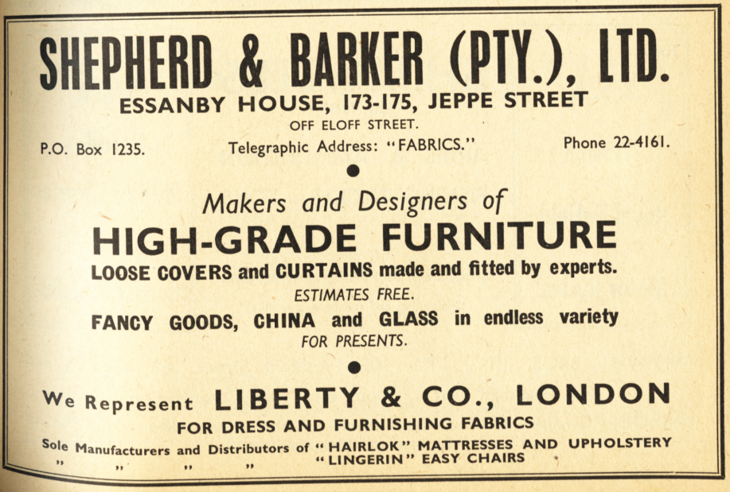

CURRENT TENANT/S:

Astor Express

SOURCES:

Published Sources
Chipkin, C.M.: Johannesburg Style; Architecture & Society 1880s – 1960s, David Philip Publishers, Cape Town, 1993.
The Rand-Pretoria Directory 1954 (Comprising Complete Alphabetical And Trades Directories of Johannesburg, Pretoria And Reef Towns), Cape Times Limited, Cape Town, 1954.
Van Der Waal, G-M.: From Mining Camp to Metropolis, The buildings of Johannesburg 1886-1940, Chris Van Rensburg Publications, Johannesburg, 1987.

Unpublished Sources
Architects In South Africa 1780 – 1940; Draft manuscript, J Walker & G M van der Waal, 1992, HSRC, Pretoria.
Johannesburg Building, Space & Urban Feature Classification, 1998: Inner City - Metropolitan Planning, Johannesburg Metropolitan Council (Cool Factory).
Plans records of surveyed buildings, Marshallstown and City of Johannesburg: Archives, Building Control, Development Management, City of Johannesburg Metropolitan Municipality.

Opname Historiese Geboue In Johannesburg, Second Report June 1976, Inner City, RAU, unpublished.

Van Der Waal, G-M.: Die Karakter Van Die Argitektuur In Die Binnestad Van Johannesburg Tot 1920, unpublished thesis, RAU, November 1972.

Van Der Waal, G-M.: Die Boukuns van Johannesburg, 1886 – 1940, unpublished doctoral thesis, RAU, November 1984.

Rand Township Registry Johannesburg.

Internet GOOGLE Search on current ownerships, 2006.

http://64.233.183.104/search?q=cache:Knb5tlnhgOsJ:www.anc.org.za/anc/newsbrief/1992/news9205.25+%22essenby+House%22+%22johannesburg%22&hl=en
http://www.anc.org.za/ancdocs/pr/1994/pr0328b.html
http://www.queensu.ca/samp/migrationnews/article.php?Mig_News_ID=1737&Mig_News_Issue=9&Mig_News_Cat=8

ASSESSMENT OF CULTURAL SIGNIFICANCE:

Historic Value:

Associated with historic person, group or organisation

Associated with historic event or activity

Architectural/Aesthetic value:

Important example of building type

Important example of a style or period

Fine details, workmanship or aesthetics

Work of a major architect or builder

Social/Spiritual/Linguistic value:

Associated with social, spiritual, linguistic, economic or political activity

Illustrates an historical period

Scientific/Technological value:

Example of industrial, technical or engineering development/achievement

New, rare or experimental building techniques

RECORDED BY:


Heritage Resources Management team Johann J Bruwer and Alezea Bruwer.

And Catharina JM Bruwer.

Photographs (unless otherwise indicated) by Johann J Bruwer and Alezea Bruwer.

